## Mini Project Report On

**SMART COLLEGE**

Submitted in partial fulfillment of the requirements for the award of the degree of

# BACHELOR OF TECHNOLOGY

In

#### COMPUTER SCIENCE AND ENGINEERING

##### Submitted By:

##### M.PRANATHI 23UP1A05F5

**Project Coordinator**

**Mr. B. Ramyasri**

Assistant Professor

**DEPARTMENT OF COMPUTER SCIENCE AND ENGINEERING**

### VIGNAN’S INSTITUTE OF MANAGEMENT AND TECHNOLOGY FOR WOMEN

**(Affiliated to JNTUH, Hyderabad, Accredited by NBA)**

**Kondapur(v), Ghatkesar(M), Medchal -Malkajgiri(D) -501301 [2023 -2027]**

#### 

**DEPARTMENT OF COMPUTER SCIENCE AND ENGINEERING**

# CERTIFICATE

This is to certify that the Project work titled **“SMART COLLEGE”** submitted by **M.PRANATHI ( 23UP1A05F5 )** of B -Tech in the partial fulfillment of the requirements for the award of the degree of Bachelor of Technology in Computer Science and Engineeringto the Vignan’s Institute of Management and Technology for Women is a record of bona -fide work carried out by them under my guidance and supervision. The results embodied in this project report have not been submitted to any university for the award of any degree and the results are achieved satisfactorily.

**Project Coordinator HEAD OF THE DEPARTMENT**

##### Mrs. B. RAMYAsri Mrs.M.PARIMALA

(Assistant Professor) (Associate Professor)

##### (External Examiner)

##### 

# DECLARATION

I, hereby declare that the results embodied in this dissertation entitled “**SMART COLLEGE**” is carried out by us during the year 2024 -2025 in partial fulfillment of the award of Bachelor of Technology in Computer Science and Engineering from VIGNAN’S INSTITUTE OF MANAGEMENT AND TECHNOLOGY FOR WOMEN is an authentic record of our work carried under the guidance of Mr. R. Krishna Nayak (Assistant Professor), Department of Computer Science and Engineering. We have not submitted the same to any other university or organization for the award of any other degree.

**M.PRANATHI(23UP1A05F5)**

**ACKNOWLEDGEMENT**

We would like to express sincere gratitude to **Dr. G. AppaRao Naidu, Principal**, **Vignan’s Institute of Management and Technology for Women** for his timely suggestions which helped us to complete the project in time.

We would also like to thank our madam **Mrs. M Parimala, Head of the Department, Computer Science and Engineering,** for providing us with constant encouragement and resources which helped us to complete the project in time.

We would like to thank our project guide**, Mrs. B.Ramyasri, Assistant Professor, Computer Science and Engineering,** for his timely cooperation and valuable suggestions throughout the project. We are indebted to his for the opportunity given to work under his guidance.

Our sincere thanks to all the teaching and non -teaching staff of the Department of Computer Science and Engineering for their support throughout our project work.

**M.PRANATHI( 23UP1A05F5)**

## Abstract

As an Engineer we solve hundreds of problems in our day-to-day life through various technologies. But today we as a group came forward with an idea which helps many Engineers to build their careers with confidence.

The Concept of smart college can one be of the emerging trend in ML in coming up years where the thought of ‘Smart Campus, Secure Campus’ may become the new mantra. Our project focus on helping the management for taking quick attendance and it also help teachers to predict which student can be able to get a placement or not. This project is also helpful in knowing about the college for newly joined students through an interactive chat bot. Furthermore, the project will present and discuss an idea about smart college using the concepts of Machine Learning.

**INDEX**

**CONTENTS PAGENO**

| 1 | Title and Description | 1 |
| --- | --- | --- |
| 1.1 | Motivation | 1 |
| 2 | Software Requriements Specification | 2 |
| 2.1 | Introduction | 2 |
| 2.1.1 | Purpose | 2 |
| 2.1.2 | Scope | 2 |
| 2.1.3 | Defintions,Acronyms and Abbreviations | 2 |
| 2.1.4 | Overview | 2 |
| 2.2 | General Description | 3 |
| 2.2.1 | Product perspective | 3 |
| 2.2.2 | Product fuctions | 3 |
| 2.2.3 | User characteristics | 3 |
| 2.3 | Modules description | 3 |
| 2.4 | System requirements | 4 |
| 2.4.1 | Hardware requirements | 4 |
| 2.4.2 | Software requirements | 4 |
| 2.5 | Design constraints | 5 |
| 4 | SYSTEM DESIGN | 5 |
| 4.1 | Architecture and techonolgy used | 5&6 |
| 4.2 | Uml diagrams | 6 |
| 4.2.1 | Use-case diagrams | 6&7 |
| 4.2.2 | Sequence diagrams | 7&8 |
| 5 | IMPLEMENTAION | 9 |
| 5.1 | System architecture | 9 |
| 5.2 | code | 9-44 |
| 6 | RESULTS | 44-54 |
| 6.1 | Datebase design | 55 |
| 7 | Testing | 56 |
| 8 | Conclusion | 57 |

|  |  |  |
| --- | --- | --- |
| 8.1 | Future scope | 57 |
| 9 | References | 58 |
|  |  |  |

# LIST OF FIGURES

| FIG | NAME | PAGE |
| --- | --- | --- |
| 5.1 | SYSTEM ARCHITECTURE | 9 |
| 4.2.1 | USE_CASE DIAGRAMS | 6&7 |
| 4.2.2 | SEQUENCE DIAGRAMS | 7&8 |

# 

# 1 TITLE DESCRIPTION

Smart College is a web application which we have developed to provide a platform to students who are lacking the interaction with the other students and adapting to the college environment needed at present and are willing to adapt those skills. Our projects help them to learn about their standards using placement prediction module.

### 1.1 Motivation

A normal student will always be perplexed about their future. The way he/she must prepare for their goals. The way he/she must update him/herself every day. In the ever-growing world with a new upcoming technology striking us every day it really is a challenge for any student to cope up with the amount of competition to secure their jobs currently. Smart College will help these students to learn the required courses for the interviews with a group learning facility and understanding where the standard with respect to current situation. It also helps the teachers to digitalize the manually taken attendance.

# 

# 2

# SOFTWARE REQUIREMENTS SPECIFICATIONS

## 2.1 Introduction

#### 2.1.1 Purpose

In search of proper platform that makes the college to digitalize completely from the attendance to placement prediction of a particular given student with respect to his skills.

#### 2.1.2 Scope

With the help of this website users(students) will be able to stabilize their thoughts on how to prepare for the interviews and what to prepare. With ever-growing technologies and a new course showing up every day. Teachers work also reduces on a huge amount of daily basis attendance in an accurate manner.

#### 2.1.3 Definitions, Acronyms and Abbreviations

#### 2.1.4 Overview

The specifications include product perspective and the functionalities that the system will provide. The user characteristics, any general constraints or assumptions and dependencies are discussed below.

Requirements are categorized as performance, non-functional requirements, and design constraints. Non-functional requirements are scalability, maintainability, and dependence.

## 

## 2.2 General Description

#### 2.2.1 Product perspective

Smart College provides features for client users such as E-college i.e., accessing the online attendance feature and prediction of their standards of skills. The current design goal is to build a system to achieve the functionality outlined in the specification.

#### 2.2.2 Product Functions

Smart College gives users a online attendance portal and placement prediction module for students.

#### 2.2.3 User Characteristics

1. **Student/user:** 
   * + The user can register in our website free of cost.
     + He/she can and access the features after logging in.
2. **Administrator:** 
   * + Admin is responsible for maintaining and updating website
     + Admin has access to database.

## 2.3 Modules Description

* **Login/Signup:**

In this module, the user can log into their respective accounts and use the website as desired. If the student is not an already existing user, he/she can create a new account by signing up.

* **Face Attendance:**

Here, the teacher can access the camera and take attendance using camera instead of manual book attendance format.

* **Placement Prediction:**

A student can predict his standards regarding placements by giving required inputs to the ML model which predicts his standards with 78% accuracy.

## 2.4 System Requirements

#### 2.4.1 Hardware Requirements

* 1GB RAM
* 1GB CORE

#### 2.4.2 Software Requirements

* **PYCHARM – 2021.3:**

PyCharm is an integrated development environment or IDE. An IDE is the primary tool for any professional programmer. PyCharm acts like a true IDE for Python, but unlike Visual Studio, PyCharm is geared specifically and only for Python development. It contains workflows for creating and maintaining virtual environments, a visual counterpart for the Pep library manager, linters that keep your code compliant with Pep 8 standards and a host of other handy general development tools.

* **INTERPRETER:**

Visual Studio Code- It features a lightning-fast source code editor, perfect for day-to-day use. With support for hundreds of languages, VS Code helps you be instantly productive with syntax highlighting, bracket-matching, auto indentation, box-selection, snippets, and more.

* **PYTHON-FLASK:**

**Flask Framework:**

**Flask** is a microweb framework written in python. It is classified as a microframework because it does not require tools or libraries. It has no database abstraction layer, form validation, or any other components where pre-existing third-party libraries provide common functions. However, Flask supports extensions that can add application features as if they were implemented in Flask itself. Extensions exist for object-relational mappers, form validation, upload handling, various open authentication technologies and several common framework related tools.

• **BOOTSTRAP- WEB DESIGNING:**

Bootstrap is a free and open-source front-end framework for designing websites and web applications. It contains HTML- and CSS-based design templates for typography, forms, buttons, navigation and other interface components, as well as optional JavaScript extensions.

## 2.5 Design Constraints

* Software Constraints: Users can run this application in windows.
* Hardware Constraints: The system will run on a core processor with minimum 400MB ram.
* Acceptance Criteria: Before accepting, the developer must check whether the application is running properly or not and should also check whether the data is stored correctly.

**SYSTEM DESIGN**

**4.1 Architecture and Technology Use**

**Front-End:**

1. HTML
2. CSS
3. JAVA SCRIPT 4) BOOTSTRAP

**Back-End:**

1. SQLlite3
2. FLASK

**Overall Architecture:**

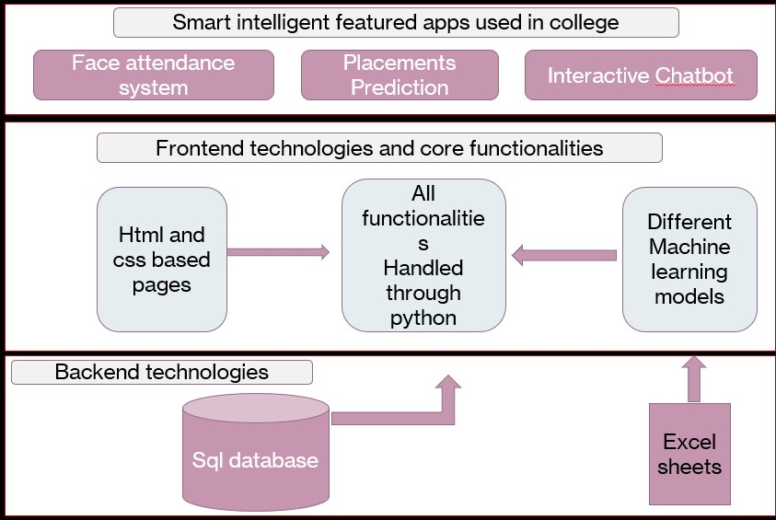

**4.2 UML Diagrams**

* + 1. **Use-case Diagram**

Use case diagrams are the diagrammatic representations depicting users' interactions with the system. This diagram shows different types of users and various ways in which these users interact with the system.

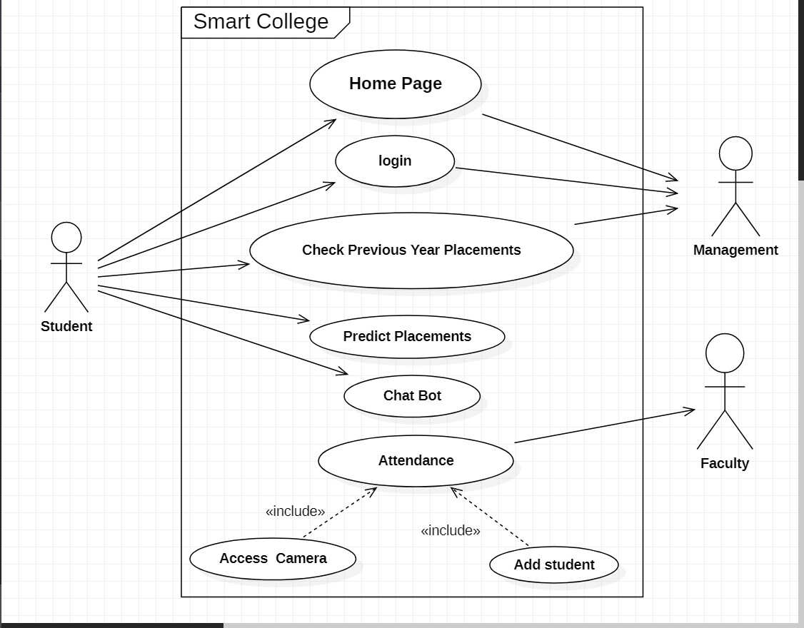

* + 1. **Sequence Diagram**

Sequence diagrams establish the roles of objects and help provide essential information to determine class responsibilities and interfaces. This type of diagram is best used during early analysis phases in design because they are simple and easy to comprehend. These are normally associated with use cases and are closely related to collaboration diagrams, and both are alternate representations of an interaction.

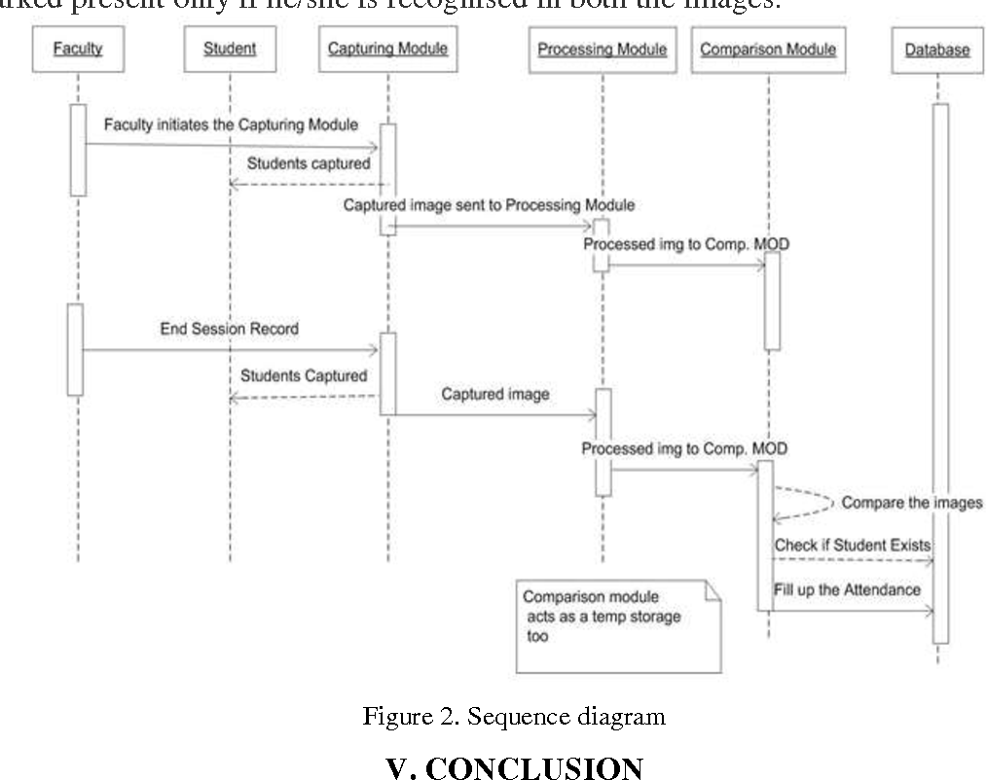

**IMPLEMENTATION**

* 1. **System Architecture (Design)**

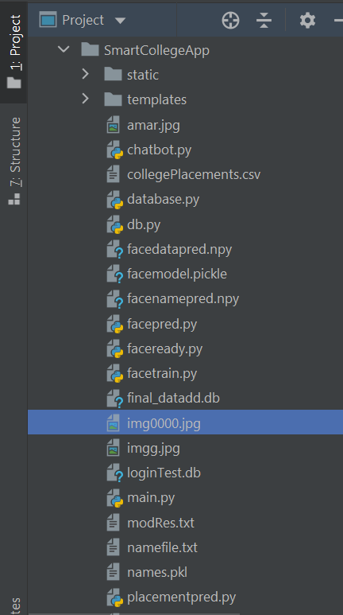

**code:**

<html>

<head>

<script type="text/javascript" src="{{ url_for('static', filename='test.js') }}"></script>

</head>

<body>

hello

{{a}}

<script>

function myFunction(var) {

alert(var);

}

let x="hello world";

myFunction(x);

</script>

</body>

</html>

**HOME.HTML**

<!DOCTYPE html>

<html style="font-size: 16px;">

<head>

<meta name="viewport" content="width=device-width, initial-scale=1.0">

<meta charset="utf-8">

<meta name="keywords" content="A Smart College App&nbsp; &nbsp; &nbsp; &nbsp; &nbsp; &nbsp; -Be Smart! Choose Smart!, About Smart College">

<meta name="description" content="">

<meta name="page_type" content="np-template-header-footer-from-plugin">

<title>Home</title>

<link rel="stylesheet" href="{{url_for('static',filename='nicepage.css')}}" media="screen">

<link rel="stylesheet" href="{{url_for('static',filename='Home.css')}}" media="screen">

<script class="u-script" type="text/javascript" src="{{url_for('static',filename='jquery.js')}}" defer=""></script>

<script class="u-script" type="text/javascript" src="{{url_for('static',filename='nicepage.js')}}" defer=""></script>

<meta name="generator" content="Nicepage 3.30.2, nicepage.com">

<link id="u-theme-google-font" rel="stylesheet" href="https://fonts.googleapis.com/css?family=Roboto:100,100i,300,300i,400,400i,500,500i,700,700i,900,900i|Open+Sans:300,300i,400,400i,600,600i,700,700i,800,800i">

<meta name="theme-color" content="#478ac9">

<meta property="og:title" content="Home">

<meta property="og:type" content="website">

</head>

<body style="background-color:LightGray;" class="u-body">

<h1 class="u-text u-text-1">

<span style="font-size: 3.4375rem;">A Smart College App</span>

<br>

<span style="font-size: 2.25rem;">&nbsp; &nbsp; &nbsp; &nbsp; &nbsp; &nbsp; -Be Smart! Choose Smart</span>!<br>

</h1>

<a href="Home.html#about">

<img src="static/about.jpg" alt="AboutUs" class="center" width="150" height="100" />

</a>

<section class="u-align-center u-clearfix u-section-2" id="sec-702a">

<div class="u-clearfix u-sheet u-sheet-1">

<h2 class="u-text u-text-default u-text-1">What this app can do?</h2>

<img class="u-image u-image-round u-radius-10 u-image-1" src= "{{url_for('static',filename='chatbot1.jpg')}}" alt="" data-image-width="294" data-image-height="171">

<img class="u-image u-image-round u-radius-10 u-image-2" src="{{url_for('static',filename='attendaceee1.jpg')}}" alt="" data-image-width="472" data-image-height="233">

<img class="u-image u-image-round u-radius-10 u-image-3" src="{{url_for('static',filename='placements.jpg')}}" alt="" data-image-width="1280" data-image-height="720">

</div>

</section>

<center>

<h1 class="u-text u-text-default u-text-1" id="about">About Smart College</h1>

<p class="u-text u-text-2">This app provides very much&nbsp;convenience to college students as well as faculty.<br>taking&nbsp; attendance is the biggest and time taking tasks for teachers so, it provides easy method for taking attendance.&nbsp; This app also allows the student to predict their placements as well they can also interactive with an chatbot which clarifies the basic questions about college

</p>

<a href="{{ url_for('Tlogin')}}" class="login" >

teacher login

</a> </br></br>

<a href="{{ url_for('Slogin')}}" class="login">Student login</a></br></br>

<a href="{{ url_for('signup')}}" data-page-id="243089129" class="login">Teacher SignUP</a></br>

<p class="u-text u-text-1">* Student can directly login With Their given&nbsp;credentials<br>

<br>

</p>

</center>

</body>

</html>

**LOGINS.HTML**

<!DOCTYPE html>

<html lang="en">

<head>

<meta charset="UTF-8">

<meta name="viewport" content="width=device-width, initial-scale=1.0">

<meta charset="utf-8">

<meta name="keywords" content="">

<meta name="description" content="">

<meta name="page_type" content="np-template-header-footer-from-plugin">

<title>Login</title>

<link rel="stylesheet" href="{{url_for('static',filename='nicepage.css')}}" media="screen">

<link rel="stylesheet" href="{{url_for('static',filename='Login.css')}}" media="screen">

<script class="u-script" type="text/javascript" src="{{url_for('static',filename='jquery.js')}}" defer=""></script>

<script class="u-script" type="text/javascript" src="{{url_for('static',filename='nicepage.js')}}" defer=""></script>

<meta name="generator" content="Nicepage 3.30.2, nicepage.com">

<link id="u-theme-google-font" rel="stylesheet" href="https://fonts.googleapis.com/css?family=Roboto:100,100i,300,300i,400,400i,500,500i,700,700i,900,900i|Open+Sans:300,300i,400,400i,600,600i,700,700i,800,800i">

<script type="application/ld+json">{

"@context": "http://schema.org",

"@type": "Organization",

"name": "",

"logo": "images/default-logo.png"

}</script>

<meta name="theme-color" content="#478ac9">

<meta property="og:title" content="Page 1">

<meta property="og:type" content="website">

</head>

<body class="u-body"><header class="u-clearfix u-header u-header" id="sec-3677"><div class="u-clearfix u-sheet u-sheet-1">

<img src="static/studentLogin.jpg" alt="AboutUs" class="center" width="300" height="300" />

</div></header>

<section class="u-align-center u-clearfix u-grey-10 u-section-1" id="sec-55fd">

<div class="u-clearfix u-sheet u-valign-middle u-sheet-1">

<div class="u-align-center u-container-style u-group u-radius-50 u-shape-round u-white u-group-1">

<div class="u-container-layout u-valign-middle u-container-layout-1">

<h3 class="u-text u-text-default u-text-1">Sign In</h3>

<div class="u-expanded-width u-form u-login-control u-form-1">

<form action="/VloginS" method="POST" class="u-clearfix u-form-custom-backend u-form-spacing-35 u-form-vertical u-inner-form" source="custom" name="form-2" style="padding: 10px;">

<div class="u-form-group u-form-name">

<label for="username-708d" class="u-form-control-hidden u-label"></label>

<input type="text" placeholder="Enter your Username" id="username-708d" name="username" class="u-grey-5 u-input u-input-rectangle" required="">

</div>

<div class="u-form-group u-form-password">

<label for="password-708d" class="u-form-control-hidden u-label"></label>

<input type="password" placeholder="Enter your Password" id="password-708d" name="password" class="u-grey-5 u-input u-input-rectangle" required="">

</div>

<div class="u-align-center u-form-group u-form-submit">

<a href="#" class="u-btn u-btn-round u-btn-submit u-button-style u-radius-17 u-btn-1">Login</a>

<input type="submit" value="submit" class="u-form-control-hidden">

</div>

<input type="hidden" value="" name="recaptchaResponse">

</form>

</div>

<p>{{ incorrect }}</p>

</div>

</div>

</div>

</section>

<footer class="u-align-center u-clearfix u-footer u-grey-80 u-footer" id="sec-0154"><div class="u-clearfix u-sheet u-sheet-1">

<p class="u-small-text u-text u-text-variant u-text-1">Sample text. Click to select the text box. Click again or double click to start editing the text.</p>

</div></footer>

<section class="u-backlink u-clearfix u-grey-80">

<a class="u-link" href="https://nicepage.com/website-templates" target="_blank">

<span>Website Templates</span>

</a>

<p class="u-text">

<span>created with</span>

</p>

<a class="u-link" href="" target="_blank">

<span>Website Builder Software</span>

</a>.

</section>

</body>

</html></title>

</head>

<body>

</body>

</html>

**LOGINT.HTML**

<!DOCTYPE html>

<html style="font-size: 16px;">

<head>

<meta name="viewport" content="width=device-width, initial-scale=1.0">

<meta charset="utf-8">

<meta name="keywords" content="">

<meta name="description" content="">

<meta name="page_type" content="np-template-header-footer-from-plugin">

<title>Login</title>

<link rel="stylesheet" href="{{url_for('static',filename='nicepage.css')}}" media="screen">

<link rel="stylesheet" href="{{url_for('static',filename='Login.css')}}" media="screen">

<script class="u-script" type="text/javascript" src="{{url_for('static',filename='jquery.js')}}" defer=""></script>

<script class="u-script" type="text/javascript" src="{{url_for('static',filename='nicepage.js')}}" defer=""></script>

<meta name="generator" content="Nicepage 3.30.2, nicepage.com">

<link id="u-theme-google-font" rel="stylesheet" href="https://fonts.googleapis.com/css?family=Roboto:100,100i,300,300i,400,400i,500,500i,700,700i,900,900i|Open+Sans:300,300i,400,400i,600,600i,700,700i,800,800i">

<script type="application/ld+json">{

"@context": "http://schema.org",

"@type": "Organization",

"name": "",

"logo": "images/default-logo.png"

}</script>

<meta name="theme-color" content="#478ac9">

<meta property="og:title" content="Page 1">

<meta property="og:type" content="website">

</head>

<body class="u-body"><header class="u-clearfix u-header u-header" id="sec-3677"><div class="u-clearfix u-sheet u-sheet-1">

<img src="static/teacherLogin.jpg" alt="AboutUs" class="centerT" width="300" height="300" />

</div></header>

<section class="u-align-center u-clearfix u-grey-10 u-section-1" id="sec-55fd">

<div class="u-clearfix u-sheet u-valign-middle u-sheet-1">

<div class="u-align-center u-container-style u-group u-radius-50 u-shape-round u-white u-group-1">

<div class="u-container-layout u-valign-middle u-container-layout-1">

<h3 class="u-text u-text-default u-text-1">Sign In</h3>

<div class="u-expanded-width u-form u-login-control u-form-1">

<form action="/VloginT" method="POST" class="u-clearfix u-form-custom-backend u-form-spacing-35 u-form-vertical u-inner-form" source="custom" name="form-2" style="padding: 10px;">

<div class="u-form-group u-form-name">

<label for="username-708d" class="u-form-control-hidden u-label"></label>

<input type="text" placeholder="Enter your Username" id="username-708d" name="username" class="u-grey-5 u-input u-input-rectangle" required="">

</div>

<div class="u-form-group u-form-password">

<label for="password-708d" class="u-form-control-hidden u-label"></label>

<input type="password" placeholder="Enter your Password" id="password-708d" name="password" class="u-grey-5 u-input u-input-rectangle" required="">

</div>

<div class="u-align-center u-form-group u-form-submit">

<a href="#" class="u-btn u-btn-round u-btn-submit u-button-style u-radius-17 u-btn-1">Login</a>

<input type="submit" value="submit" class="u-form-control-hidden">

</div>

<input type="hidden" value="" name="recaptchaResponse">

</form>

<p>{{ incorrect }}</p>

</div>

</div>

</section>

<footer class="u-align-center u-clearfix u-footer u-grey-80 u-footer" id="sec-0154"><div class="u-clearfix u-sheet u-sheet-1">

<p class="u-small-text u-text u-text-variant u-text-1">Sample text. Click to select the text box. Click again or double click to start editing the text.</p>

</div></footer>

<section class="u-backlink u-clearfix u-grey-80">

<a class="u-link" href="https://nicepage.com/website-templates" target="_blank">

<span>Website Templates</span>

</a>

<p class="u-text">

<span>created with</span>

</p>

<a class="u-link" href="" target="_blank">

<span>Website Builder Software</span>

</a>.

</section>

</body>

</html>

**SIGNUP.HTML**

<!DOCTYPE html>

<html style="font-size: 16px;">

<head>

<meta name="viewport" content="width=device-width, initial-scale=1.0">

<meta charset="utf-8">

<meta name="keywords" content="A Smart College App&nbsp; &nbsp; &nbsp; &nbsp; &nbsp; &nbsp; -Be Smart! Choose Smart!">

<meta name="description" content="">

<meta name="page_type" content="np-template-header-footer-from-plugin">

<title>Sign Up</title>

<link rel="stylesheet" href="{{url_for('static',filename='nicepage.css')}}" media="screen">

<link rel="stylesheet" href="{{url_for('static',filename='Sign-Up.css')}}" media="screen">

<script class="u-script" type="text/javascript" src="{{url_for('static',filename='jquery.js')}}" defer=""></script>

<script class="u-script" type="text/javascript" src="{{url_for('static',filename='nicepage.js')}}" defer=""></script>

<meta name="generator" content="Nicepage 3.30.2, nicepage.com">

<link id="u-theme-google-font" rel="stylesheet" href="https://fonts.googleapis.com/css?family=Roboto:100,100i,300,300i,400,400i,500,500i,700,700i,900,900i|Open+Sans:300,300i,400,400i,600,600i,700,700i,800,800i">

<link id="u-page-google-font" rel="stylesheet" href="https://fonts.googleapis.com/css?family=Montserrat:100,100i,200,200i,300,300i,400,400i,500,500i,600,600i,700,700i,800,800i,900,900i">

<script type="application/ld+json">{

"@context": "http://schema.org",

"@type": "Organization",

"name": ""

}</script>

<meta name="theme-color" content="#478ac9">

<meta property="og:title" content="Sign Up">

<meta property="og:type" content="website">

</head>

<body class="u-body">

<section class="u-align-center u-clearfix u-image u-section-1" id="carousel_8ceb" data-image-width="810" data-image-height="1080">

<div class="u-clearfix u-sheet u-sheet-1">

<div class="u-palette-3-base u-shape u-shape-rectangle u-shape-1"></div>

<div class="u-container-style u-group u-radius-50 u-shape-round u-white u-group-1">

<div class="u-container-layout u-container-layout-1">

<h2 class="u-align-center u-custom-font u-font-montserrat u-text u-text-1">SignUp</h2>

<div class="u-form u-form-1">

<form action="/faculty" method="POST" class="u-clearfix u-form-spacing-13 u-form-vertical u-inner-form" style="padding: 0;" source="custom" name="form">

<div class="u-form-group u-form-name u-form-partition-factor-2">

<label for="name-f18c" class="u-label u-label-1">Name</label>

<input type="text" placeholder="Enter your Name" id="name-f18c" name="name" class="u-grey-5 u-input u-input-rectangle u-input-1" required="">

</div>

<div class="u-form-email u-form-group u-form-partition-factor-2">

<label for="email-f18c" class="u-label u-label-2">Department</label>

<input type="text" placeholder="" id="email-f18c" name="number" class="u-grey-5 u-input u-input-rectangle u-input-2" required="">

</div>

<div class="u-form-group u-form-phone u-form-group-3">

<label for="phone-cbff" class="u-label u-label-3" wfd-invisible="true">Phone</label>

<input type="tel" pattern="\+?\d{0,2}[\s\(\-]?([0-9]{3})[\s\)\-]?([\s\-]?)([0-9]{3})[\s\-]?([0-9]{2})[\s\-]?([0-9]{2})" placeholder="Enter your phone (e.g. +14155552675)" id="phone-cbff" name="number-1" class="u-grey-5 u-input u-input-rectangle u-input-3" required="">

</div>

<div class="u-form-group u-form-group-4">

<label for="text-bcbc" class="u-label u-label-4">Address</label>

<input type="text" placeholder="" id="text-bcbc" name="text" class="u-grey-5 u-input u-input-rectangle u-input-4">

</div>

<div class="u-form-group u-form-group-5">

<label for="text-3c99" class="u-label u-label-5">New Password</label>

<input type="text" placeholder="" id="text-3c99" name="text-1" class="u-grey-5 u-input u-input-rectangle u-input-5">

</div>

<div class="u-form-group u-form-group-6">

<label for="text-3a00" class="u-label u-label-6">Security Number</label>

<input type="text" placeholder="" id="text-3a00" name="number-2" class="u-grey-5 u-input u-input-rectangle u-input-6">

</div>

<div class="u-align-center u-form-group u-form-submit">

<a href="#" class="u-border-none u-btn u-btn-submit u-button-style u-palette-3-base u-btn-1">Submit</a>

<input type="submit" value="submit" class="u-form-control-hidden" wfd-invisible="true">

</div>

<!--<div class="u-form-send-message u-form-send-success" wfd-invisible="true"> Thank you! Your message has been sent. </div>-->

<div class="u-form-send-error u-form-send-message" wfd-invisible="true"> Thank you! Your message has been sent. </div>

<input type="hidden" value="" name="recaptchaResponse" wfd-invisible="true">

<input type="hidden" value="" name="faculty" id="faculty">

</form>

</div>

</div>

</div>

</div>

</section>

<a></a>

</body>

</html>

**STUDENT.HTML**

<!DOCTYPE html>

<html style="font-size: 16px;">

<head>

<meta name="viewport" content="width=device-width, initial-scale=1.0"> <meta charset="utf-8">

<meta name="keywords" content="Welcome To Students​, You can predict your placements, You can chat with our chat bot here, See previous year placements">

<meta name="description" content="">

<meta name="page_type" content="np-template-header-footer-from-plugin">

<title>Student</title>

<link rel="stylesheet" href="{{url_for('static',filename='nicepage.css')}}" media="screen"><link rel="stylesheet" href="{{url_for('static',filename='Student.css')}}" media="screen"> <script class="u-script" type="text/javascript" src="{{url_for('static',filename='jquery.js')}}" defer=""></script> <script class="u-script" type="text/javascript" src="{{url_for('static',filename='nicepage.js')}}" defer=""></script> <meta name="generator" content="Nicepage 4.1.0, nicepage.com"> <link id="u-theme-google-font" rel="stylesheet" href="https://fonts.googleapis.com/css?family=Roboto:100,100i,300,300i,400,400i,500,500i,700,700i,900,900i|Open+Sans:300,300i,400,400i,600,600i,700,700i,800,800i"> <script type="application/ld+json">{ "@context": "http://schema.org", "@type": "Organization", "name": "", "logo": "images/default-logo.png"}</script> <meta name="theme-color" content="#478ac9"> <meta property="og:title" content="Student"> <meta property="og:type" content="website"> </head> <body class="u-body u-image" style="background-position: 50% 50%; background-image: url(&quot;images/default-image.jpg&quot;);"><header class="u-clearfix u-header u-header" id="sec-13a6"><div class="u-clearfix u-sheet u-sheet-1"> <a href="https://nicepage.com" class="u-image u-logo u-image-1"> <img src="images/default-logo.png" class="u-logo-image u-logo-image-1"> </a> <h2 class="u-align-center u-subtitle u-text u-text-1"> A Smart College App<br>&nbsp; &nbsp; &nbsp; &nbsp; &nbsp; &nbsp; -Be Smart! Choose Smart! </h2> </div></header> <section class="u-align-center u-clearfix u-image u-section-1" src="{{url_for('static',filename='studentB.jpg')}}" data-image-width="500" data-image-height="350" id="sec-88b6"> <div class="u-clearfix u-sheet u-sheet-1"> <h1 class="u-text u-text-default u-title u-text-1"> <span style="font-size: 3.75rem;">Welcome To Students</span> <span style="font-size: 3rem;"></span> </h1> <h2 class="u-subtitle u-text u-text-2">You can predict your placements</h2> <a href="{{url_for('placements')}}" data-page-id="2671620571" class="u-btn u-button-style u-palette-2-base u-btn-1" target="_blank">Predict</a> <h2 class="u-text u-text-3">You can chat with our chat bot here</h2> <a href="/chatbot" class="u-btn u-btn-round u-button-style u-gradient u-hover-palette-1-base u-none u-radius-50 u-text-body-alt-color u-text-hover-palette-3-base u-btn-2" target="_blank"><span class="u-icon u-icon-1"><svg class="u-svg-content" viewBox="0 0 490.667 490.667" x="0px" y="0px" style="width: 1em; height: 1em;"><circle cx="245.333" cy="160" r="74.667"></circle><circle cx="394.667" cy="224" r="53.333"></circle><circle cx="97.515" cy="224" r="53.333"></circle><path d="M245.333,256c-76.459,0-138.667,62.208-138.667,138.667c0,5.888,4.779,10.667,10.667,10.667h256 c5.888,0,10.667-4.779,10.667-10.667C384,318.208,321.792,256,245.333,256z"></path><path d="M115.904,300.971c-6.528-1.387-13.163-2.304-19.904-2.304c-52.928,0-96,43.072-96,96c0,5.888,4.779,10.667,10.667,10.667 h76.629c-1.195-3.349-1.963-6.912-1.963-10.667C85.333,359.659,96.768,327.339,115.904,300.971z"></path><path d="M394.667,298.667c-6.741,0-13.376,0.917-19.904,2.304c19.136,26.368,30.571,58.688,30.571,93.696 c0,3.755-0.768,7.317-1.963,10.667H480c5.888,0,10.667-4.779,10.667-10.667C490.667,341.739,447.595,298.667,394.667,298.667z"></path></svg><img></span>&nbsp;Chat with bot </a> <!-- <h2 class="u-subtitle u-text u-text-4">See previous year placements</h2> <a href="" class="u-border-none u-btn u-btn-round u-button-style u-hover-palette-1-light-1 u-palette-2-base u-radius-50 u-btn-3">click</a> --> </div> </section>

</body>

</html>

‎**TEACHER.HTML**

<!DOCTYPE html>

<html lang="en">

<head>

<meta charset="UTF-8">

<title>teacher schedule</title>

</head>

<body>

<table Border="2">

<tr>

<th>9:40-10:40</th>

<th>10:40-11:40</th>

<th>11:40-12:40</th>

</tr>

<tr>

<th>IT-A</th>

<th>IT-B</th>

<th>IT-C</th>

</tr>

<tr>

<th>CSE-A</th>

<th>IT-B</th>

<th>CSE-C</th>

</tr>

<tr>

<th>EEE-A</th>

<th>ECE-B</th>

<th>MECH-C</th>

</tr>

</table>

</body>

</html>

**CAMERA.HTML**

<!DOCTYPE html>

<html lang="en">

<head>

<meta charset="UTF-8">

<meta name="viewport" content="width=device-width, initial-scale=1.0">

<title>get_capture</title>

</head>

<br>

<body>

<h3>Capture Image by pressing the space key </h3>

<video id="video" width="540" height="380" autoplay></video>

<br>

<canvas id="canvas" class="canvas-wrapper"></canvas>

<a href="{{ url_for('success')}}" ><button>Post another</button><br>

</a>

</body>

<script src="{{url_for('static', filename='main.js')}}"></script>

<style>

/*Hide canvas*/

#canvas {

display: none !important;

}

</style>

</html>

**PLACEMENTS.HTML**  
<!DOCTYPE html>

<html style="font-size: 16px;">

<head>

<meta name="viewport" content="width=device-width, initial-scale=1.0">

<meta charset="utf-8">

<meta name="keywords" content="A Smart College App&nbsp; &nbsp; &nbsp; &nbsp; &nbsp; &nbsp; -Be Smart! Choose Smart!, Predict YOur placements">

<meta name="description" content="">

<meta name="page_type" content="np-template-header-footer-from-plugin">

<title>placements</title>

<link rel="stylesheet" href="{{url_for('static',filename='nicepage.css')}}" media="screen">

<link rel="stylesheet" href="{{url_for('static',filename='placements.css')}}" media="screen">

<script class="u-script" type="text/javascript" src="{{url_for('static',filename='jquery.js')}}" defer=""></script>

<script class="u-script" type="text/javascript" src="{{url_for('static',filename='nicepage.js')}}" defer=""></script>

<meta name="generator" content="Nicepage 3.30.2, nicepage.com">

<link id="u-theme-google-font" rel="stylesheet" href="https://fonts.googleapis.com/css?family=Roboto:100,100i,300,300i,400,400i,500,500i,700,700i,900,900i|Open+Sans:300,300i,400,400i,600,600i,700,700i,800,800i">

<script type="application/ld+json">{

"@context": "http://schema.org",

"@type": "Organization",

"name": ""

}</script>

<meta name="theme-color" content="#478ac9">

<meta property="og:title" content="placements">

<meta property="og:type" content="website">

</head>

<body class="u-body"><header class="u-clearfix u-header u-image u-header" id="sec-81ed" data-image-width="1280" data-image-height="851"><div class="u-clearfix u-sheet u-sheet-1">

<h1 class="u-text u-text-1">

<span class="u-text-palette-5-light-1" style="font-weight: 700;">

<span style="font-size: 3.4375rem;">A Smart College App</span>

<br>

<span style="font-size: 2.25rem;">&nbsp; &nbsp; &nbsp; &nbsp; &nbsp; &nbsp; -Be Smart! Choose Smart</span>!

</span>

<br>

</h1>

<a href="Home.html#sec-a5ff" data-page-id="902212712" class="u-btn u-button-style u-gradient u-none u-text-body-alt-color u-btn-1">about</a>

<a href="Home.html" data-page-id="902212712" class="u-btn u-button-style u-gradient u-none u-text-body-alt-color u-btn-2">HOME<span style="font-size: 1.875rem;"></span>

</a>

</div></header>

<section class="u-clearfix u-valign-middle-xl u-section-1" id="carousel_f7c9">

<div class="u-expanded-height-lg u-expanded-height-md u-expanded-height-xl u-expanded-width-sm u-expanded-width-xs u-palette-1-base u-shape u-shape-rectangle u-shape-1"></div>

<div class="u-clearfix u-gutter-0 u-layout-wrap u-layout-wrap-1">

<div class="u-gutter-0 u-layout">

<div class="u-layout-row">

<div class="u-size-28">

<div class="u-layout-col">

<div class="u-align-left u-container-style u-image u-layout-cell u-left-cell u-size-60 u-image-1" data-image-width="1200" data-image-height="630">

<div class="u-container-layout u-container-layout-1"></div>

</div>

</div>

</div>

<div class="u-size-32">

<div class="u-layout-row">

<div class="u-container-style u-layout-cell u-right-cell u-size-60 u-layout-cell-2">

<div class="u-container-layout u-container-layout-2">

<h2 class="u-text u-text-default u-text-1">Predict YOur placements</h2>

<div class="u-expanded-width u-form u-form-1">

<form action="/placepred" method="POST" class="u-block-da90-21 u-clearfix u-form-spacing-25 u-form-vertical u-inner-form" source="custom"><!-- hidden inputs for siteId and pageId -->

<div class="u-form-group u-form-name">

<label for="name-e4cc" class="u-label">Age</label>

<input type="text" placeholder="Enter your age" id="name-e4cc" name="number" class="u-border-no-bottom u-border-no-left u-border-no-right u-border-no-top u-grey-5 u-input u-input-rectangle" required="">

</div><!-- always visible -->

<div class="u-form-group u-form-group-2">

<label for="text-3ab8" class="u-label">internship</label>

<input type="text" placeholder="Number of internships" id="text-3ab8" name="number-1" class="u-border-no-bottom u-border-no-left u-border-no-right u-border-no-top u-grey-5 u-input u-input-rectangle">

</div>

<div class="u-form-group u-form-group-3">

<label for="text-c64d" class="u-label">Cgpa</label>

<input type="text" placeholder="Enter your Cgpa" id="text-c64d" name="number-2" class="u-border-no-bottom u-border-no-left u-border-no-right u-border-no-top u-grey-5 u-input u-input-rectangle">

</div>

<div class="u-form-group u-form-group-4">

<label for="text-f07b" class="u-label">backlogs</label>

<input type="text" placeholder="number of backlogs" id="text-f07b" name="number-3" class="u-border-no-bottom u-border-no-left u-border-no-right u-border-no-top u-grey-5 u-input u-input-rectangle">

</div>

<div class="u-form-group u-form-group-5">

<label for="text-ea27" class="u-label">Data Structures</label>

<input type="text" placeholder="datastructures marks" id="text-ea27" name="number-5" class="u-border-no-bottom u-border-no-left u-border-no-right u-border-no-top u-grey-5 u-input u-input-rectangle">

</div>

<div class="u-form-group u-form-group-6">

<label for="text-5268" class="u-label">aptitude</label>

<input type="text" placeholder="aptitude marks" id="text-5268" name="number-4" class="u-border-no-bottom u-border-no-left u-border-no-right u-border-no-top u-grey-5 u-input u-input-rectangle">

</div>

<div class="u-form-group u-form-select u-form-group-7">

<label for="select-8f1f" class="u-form-control-hidden u-label"></label>

<div class="u-form-select-wrapper">

<select id="select-8f1f" name="select" class="u-border-no-bottom u-border-no-left u-border-no-right u-border-no-top u-grey-5 u-input u-input-rectangle">

<option value="Civil">Civil</option>

<option value="Computer Science">Computer Science</option>

<option value="Electrical">Electrical</option>

<option value="ECE">ECE</option>

<option value="Information Technology">Information Technology</option>

<option value="Mechanical">Mechanical</option>

</select>

<svg xmlns="http://www.w3.org/2000/svg" width="14" height="12" version="1" class="u-caret"><path fill="currentColor" d="M4 8L0 4h8z"></path></svg>

</div>

</div>

<div class="u-form-group u-form-group-8">

<label for="text-ab71" class="u-label">gender</label>

<input type="text" placeholder="Enter your gender" id="text-ab71" name="text" class="u-border-no-bottom u-border-no-left u-border-no-right u-border-no-top u-grey-5 u-input u-input-rectangle">

</div>

<div class="u-form-group u-form-submit">

<a href="#" class="u-btn u-btn-submit u-button-style u-hover-palette-1-dark-1 u-palette-1-base u-btn-1">Submit the form</a>

<div class="u-form-send-error u-form-send-message" wfd-invisible="true"> Thank you! Your details has been reorded. </div>

<!--<input type="hidden" value="" name="recaptchaResponse" wfd-invisible="true">-->

<input type="submit" value="submit" class="u-form-control-hidden u-grey-5">

</div>

</form>

</div>

</div>

</div>

</div>

</div>

</div>

</div>

</div>

</section>

<a href="{{url_for('placepredsucc')}}" >Click Here To check</a>

<footer class="u-align-center u-clearfix u-footer u-grey-80 u-footer" id="sec-1f7b"><div class="u-align-left u-clearfix u-sheet u-sheet-1"></div></footer>

<section class="u-backlink u-clearfix u-grey-80">

<a class="u-link" href="https://nicepage.com/website-design" target="_blank">

<span>Website Design</span>

</a>

<p class="u-text">

<span>created with</span>

</p>

<a class="u-link" href="" target="_blank">

<span>Website Builder Software</span>

</a>.

</section>

</body>

</html>

**PLACEPREDFAIL.HTML**

<!DOCTYPE html>

<html lang="en">

<head>

<meta charset="UTF-8">

<title>placment</title>

</head>

<body>

<h1>sorry You will not get placement!</h1>

</body>

</html>

**PLACEPREDSUCC.HTML**

<!DOCTYPE html>

<html lang="en">

<head>

<meta charset="UTF-8">

<title>hiiiii</title>

</head>

<body>

<h1>You will get placement!</h1>

</body>

</html>

**SCUSSES.HTML**

<!DOCTYPE html>

<html lang="en">

<head>

<meta charset="UTF-8">

</head>

<body>

<h1>attendance posted succesfully for {{name}}</h1>

<h3>want to post another one?</h3>

<a href="{{ url_for('cameraa')}}"> click here!<br></a>

<h3>

Or redirect to home page?

</h3>

<a href="{{ url_for('welcome')}}"> Click here!<br></a>

</body>

</html>

**TEACHERLOGIN.HTML**

<!DOCTYPE html>

<html style="font-size: 16px;">

<head>

<meta name="viewport" content="width=device-width, initial-scale=1.0">

<meta charset="utf-8">

<meta name="keywords" content="Smart college, Welcome To Faculty you can take attendance here!, Instructions for attendance​">

<meta name="description" content="">

<meta name="page_type" content="np-template-header-footer-from-plugin">

<title>teacherLogin</title>

<link rel="stylesheet" href="{{url_for('static',filename='nicepage.css')}}" media="screen">

<link rel="stylesheet" href="{{url_for('static',filename='Login.css')}}" media="screen">

<script class="u-script" type="text/javascript" src="{{url_for('static',filename='jquery.js')}}" defer=""></script>

<script class="u-script" type="text/javascript" src="{{url_for('static',filename='nicepage.js')}}" defer=""></script>

<meta name="generator" content="Nicepage 3.30.2, nicepage.com">

<link id="u-theme-google-font" rel="stylesheet" href="https://fonts.googleapis.com/css?family=Roboto:100,100i,300,300i,400,400i,500,500i,700,700i,900,900i|Open+Sans:300,300i,400,400i,600,600i,700,700i,800,800i">

<script type="application/ld+json">{

"@context": "http://schema.org",

"@type": "Organization",

"name": ""

}</script>

<meta name="theme-color" content="#478ac9">

<meta property="og:title" content="teacherLogin">

<meta property="og:type" content="website">

</head>

<body class="u-body"><header class="u-clearfix u-header u-image u-header" id="sec-3677" data-image-width="386" data-image-height="257"><div class="u-clearfix u-sheet u-sheet-1">

<h1 class="u-text u-text-default u-text-white u-text-1">Smart college</h1>

<h2 class="u-text u-text-2">Welcome To Faculty you can take attendance here!</h2>

<div class="u-clearfix u-gutter-0 u-layout-wrap u-layout-wrap-1">

<div class="u-layout" style="">

<div class="u-layout-row" style="">

<div class="u-container-style u-layout-cell u-right-cell u-size-60 u-size-xs-60 u-layout-cell-1" src="">

<div class="u-container-layout u-container-layout-1" src="">

<h2 class="u-text u-text-default u-text-3">Instructions for attendance​&nbsp;</h2>

<img class="u-image u-image-1" src="images/face.jpg" data-image-width="315" data-image-height="160">

<p class="u-text u-text-4">*&nbsp; Click On Start camera *<br>* show the face of student to camera *&nbsp;<br>* click on snap *<br>* You will get a confirmation after taking attendance sucessfully!&nbsp; *

</p>

<a href="https://nicepage.cloud" class="u-btn u-btn-round u-button-style u-gradient u-none u-radius-4 u-text-body-alt-color u-btn-1">Start Camera</a>

<p class="u-text u-text-5">For&nbsp; Registering new face Click here&nbsp;</p>

<a href="https://nicepage.com/k/ranking-website-templates" class="u-border-2 u-border-hover-palette-1-base u-border-palette-4-light-2 u-btn u-btn-round u-button-style u-hover-palette-1-base u-palette-1-light-2 u-radius-50 u-text-palette-5-dark-3 u-btn-2">Register A new Student</a>

</div>

</div>

</div>

</div>

</div>

</div></header>

<footer class="u-align-center u-clearfix u-footer u-grey-80 u-footer" id="sec-0154"><div class="u-clearfix u-sheet u-sheet-1">

<p class="u-small-text u-text u-text-variant u-text-1">Sample text. Click to select the text box. Click again or double click to start editing the text.</p>

</div></footer>

<section class="u-backlink u-clearfix u-grey-80">

<a class="u-link" href="https://nicepage.com/html-templates" target="_blank">

<span>HTML Website Templates</span>

</a>

<p class="u-text">

<span>created with</span>

</p>

<a class="u-link" href="https://nicepage.com/wysiwyg-html-editor" target="_blank">

<span>WYSIWYG HTML Editor</span>

</a>.

</section>

</body>

</html>

**RESULTS**

**Home Page:**

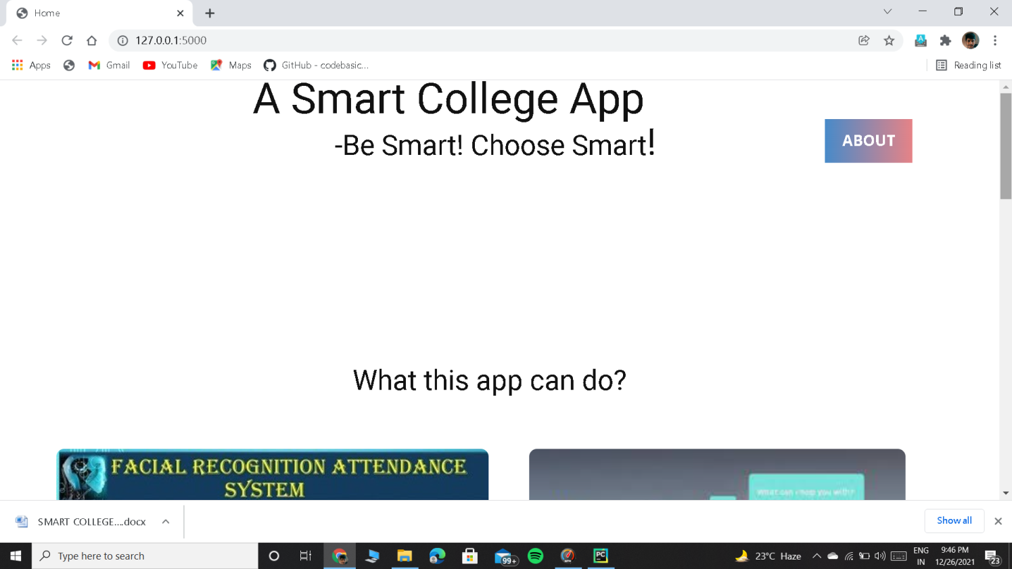

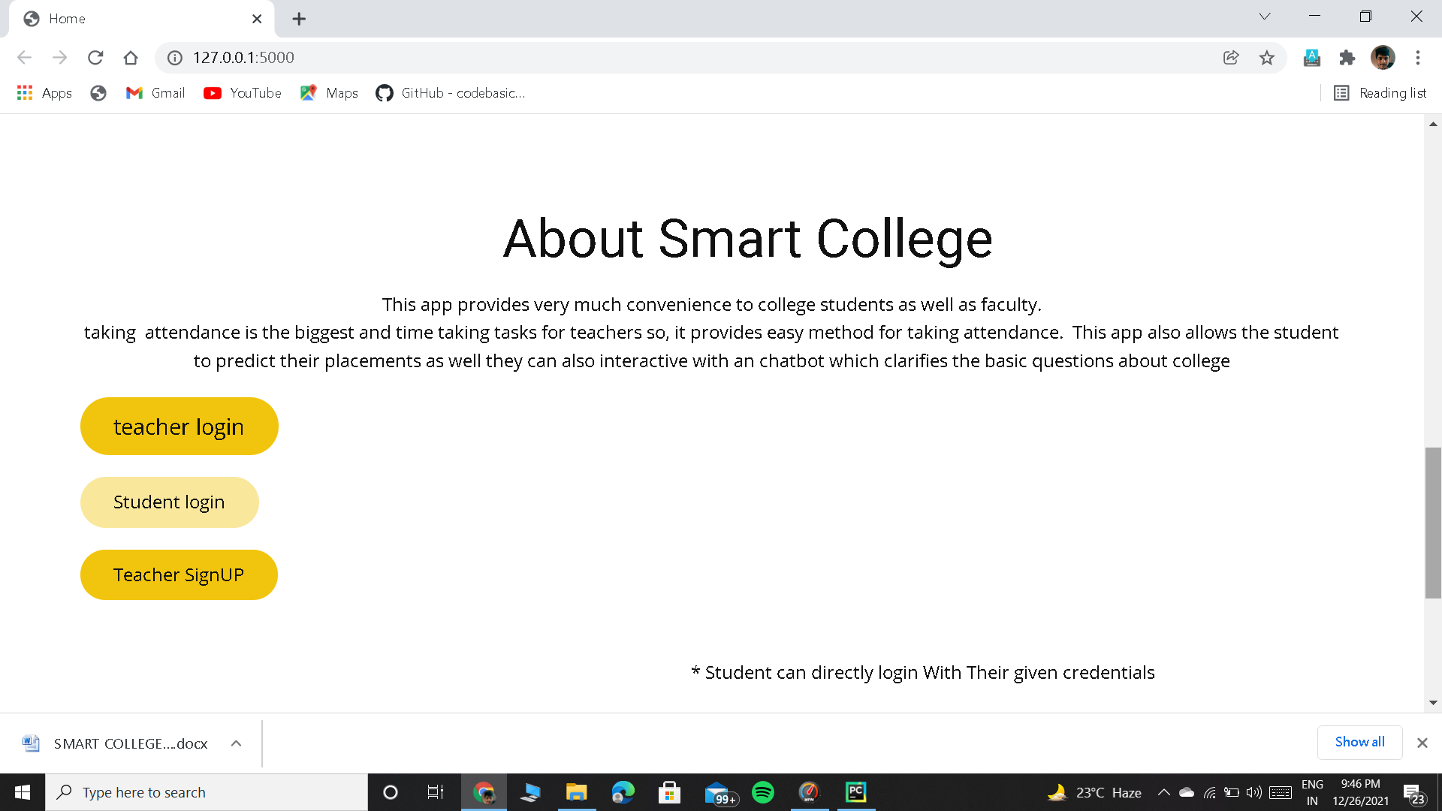

**Login Page**

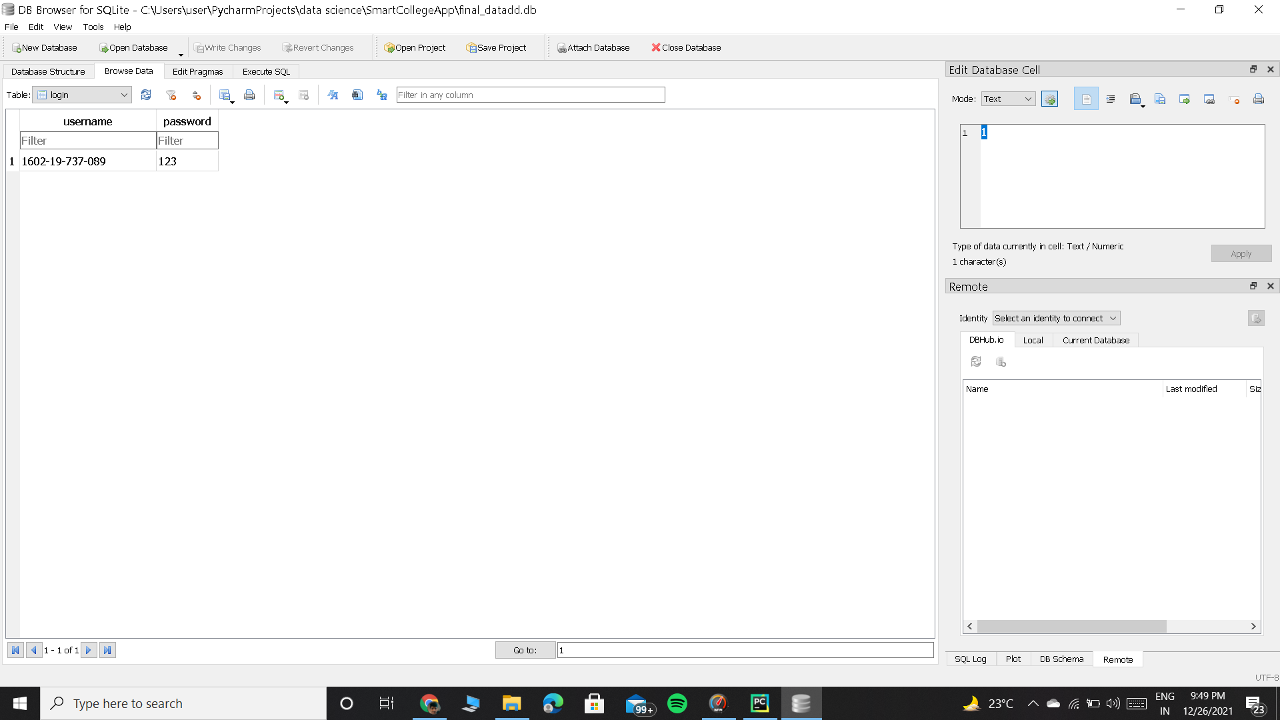

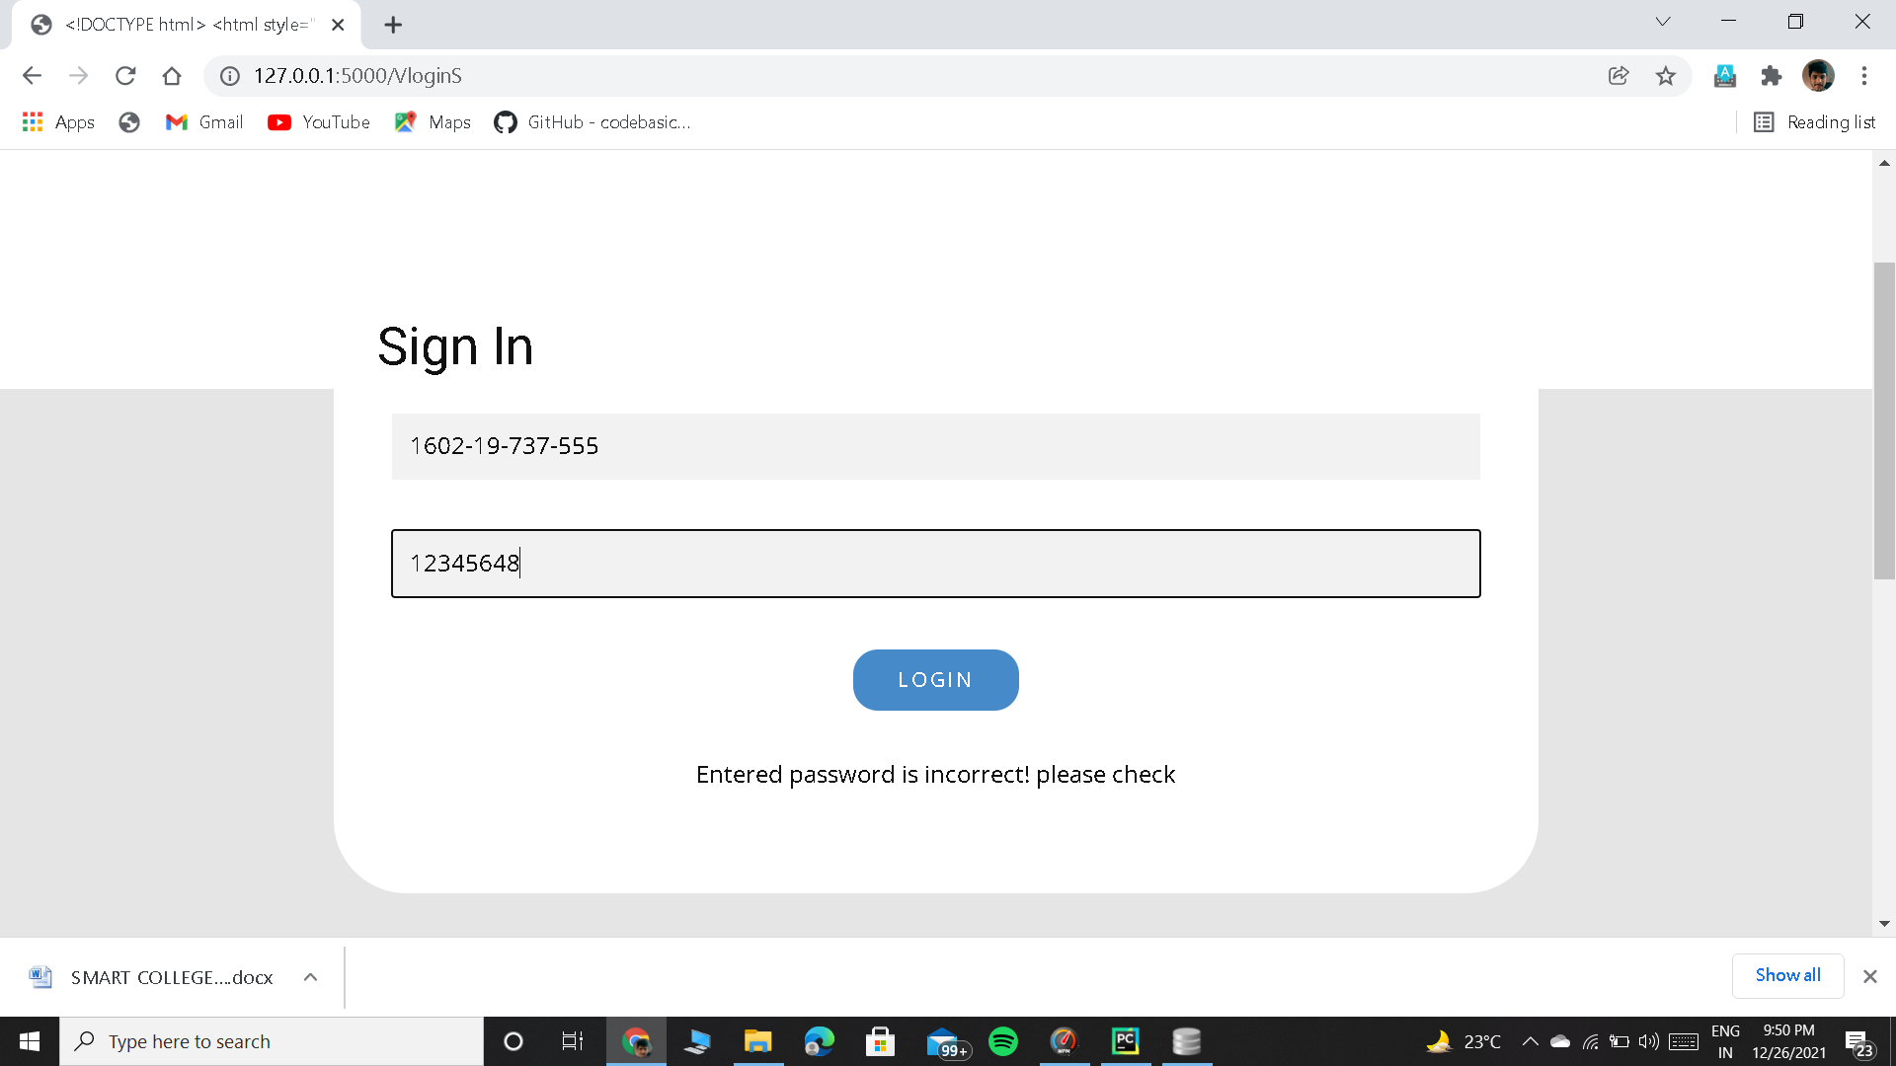

**Student page:**

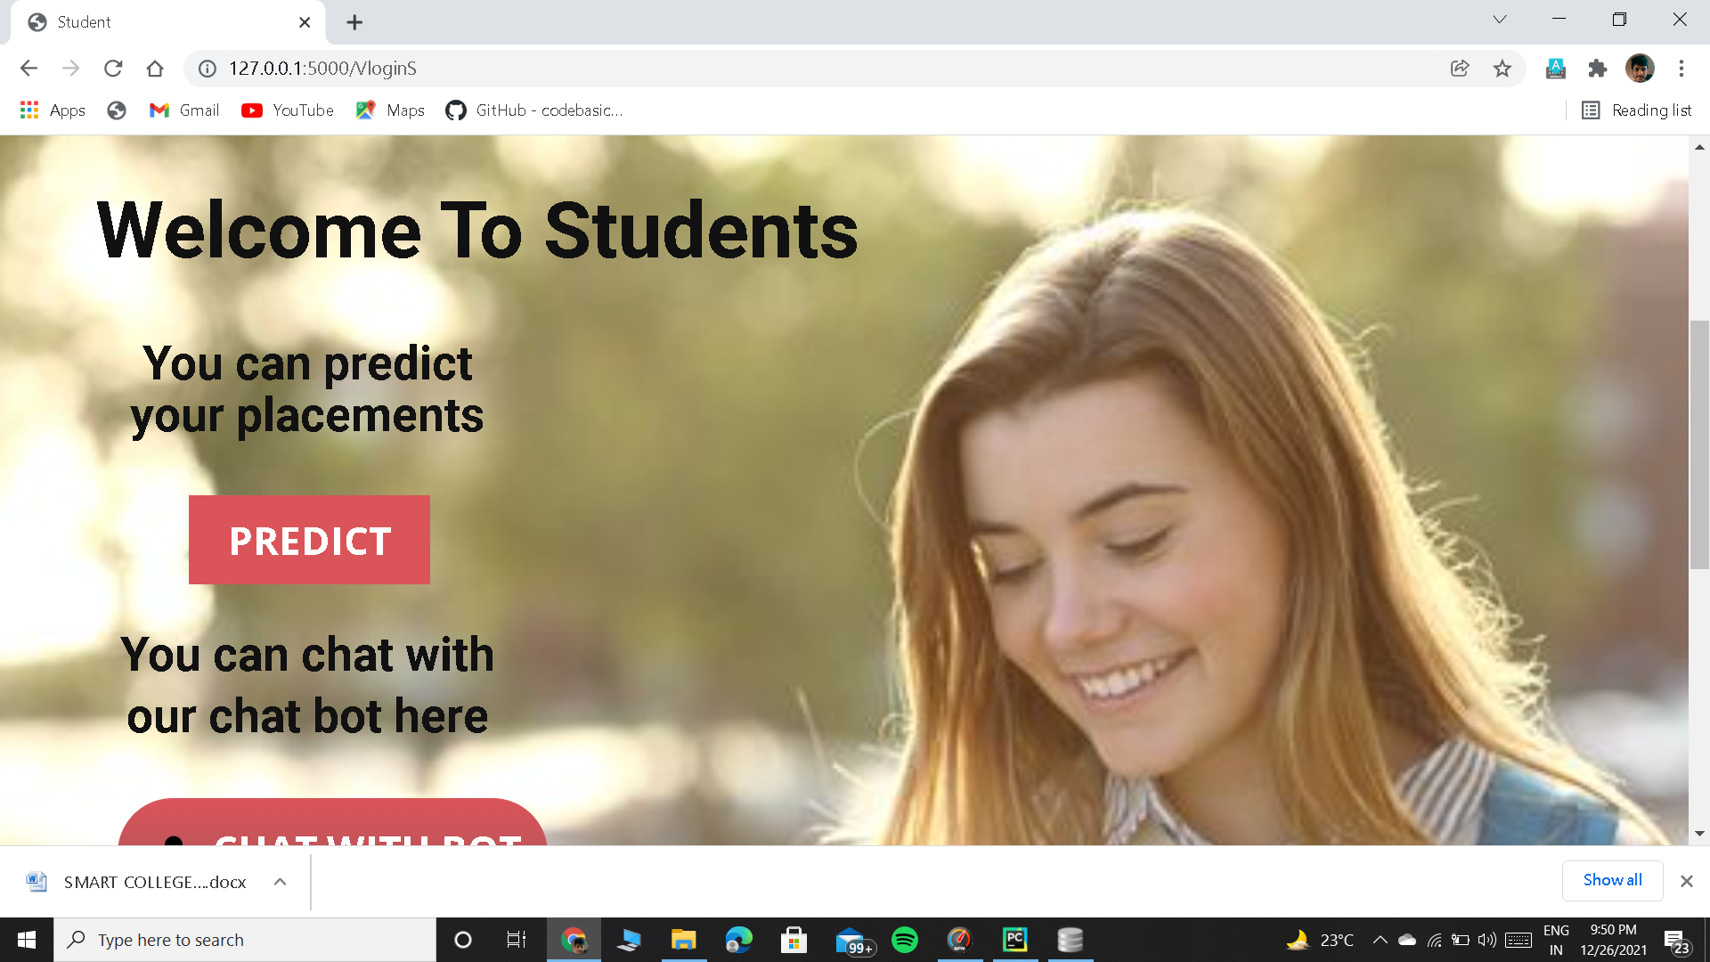

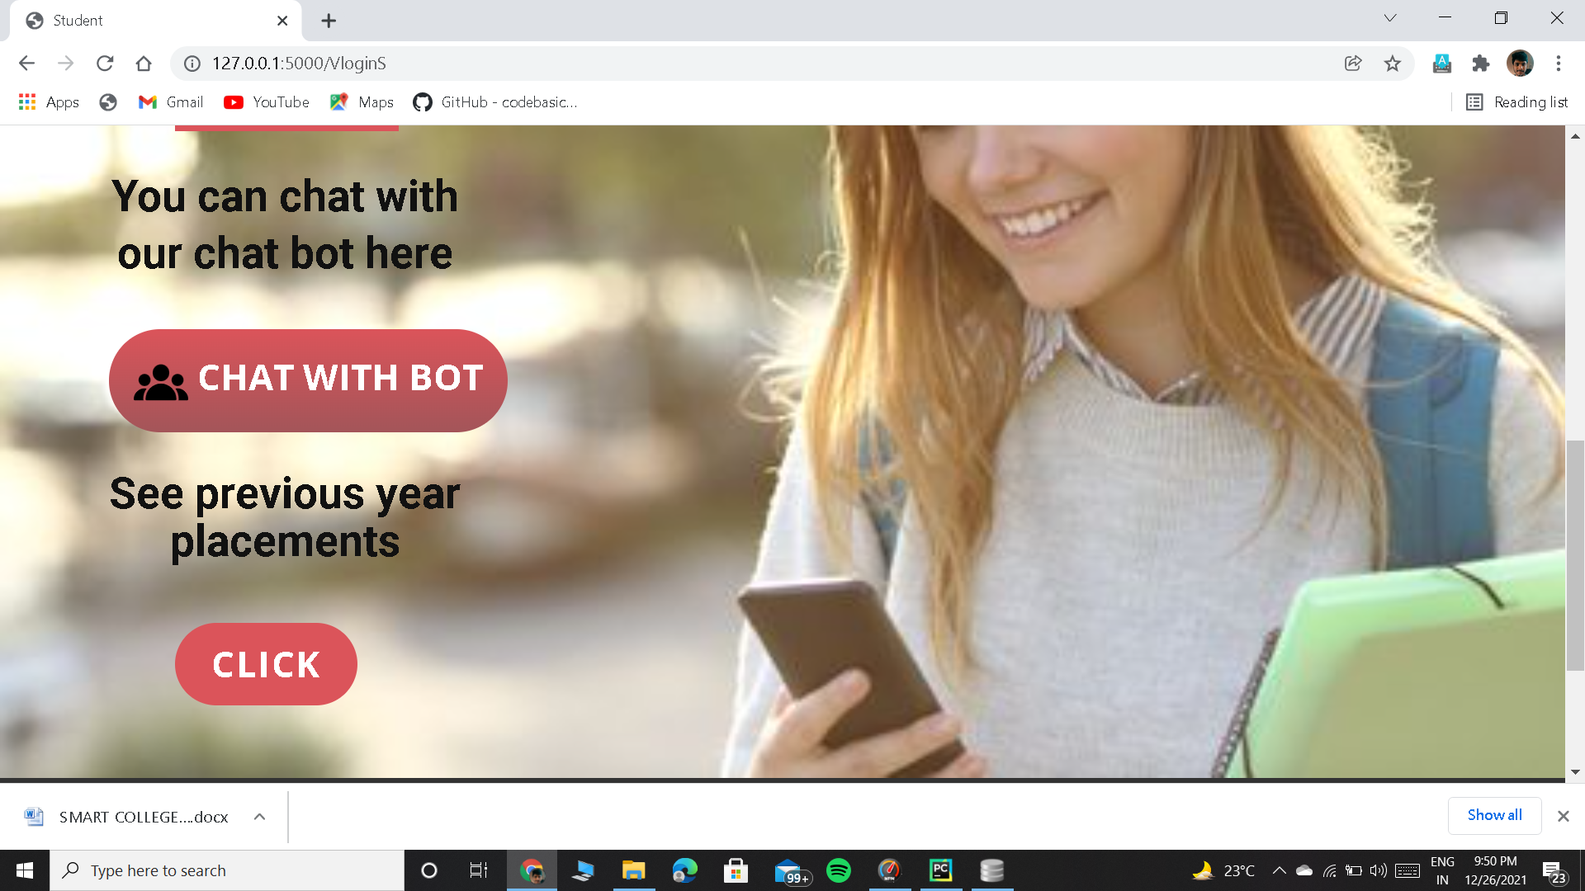

**Placement Prediction**

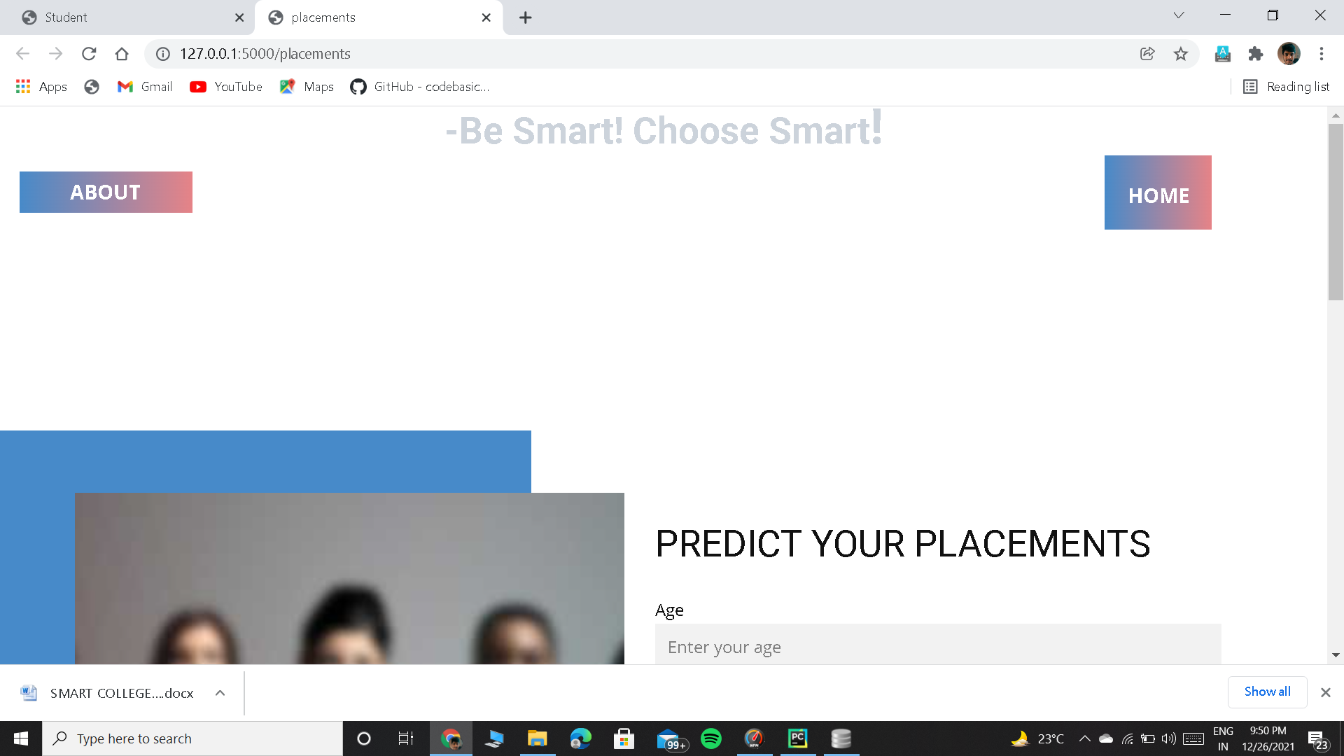

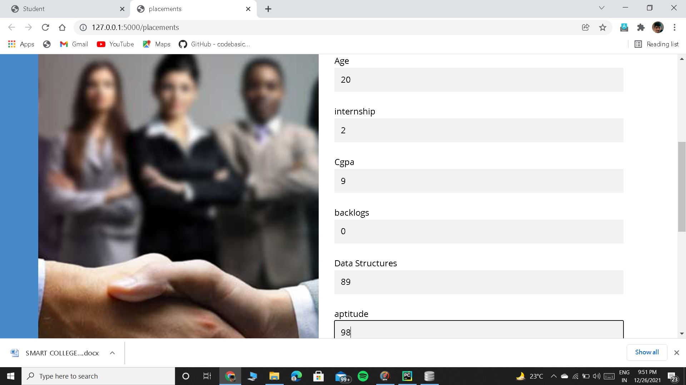

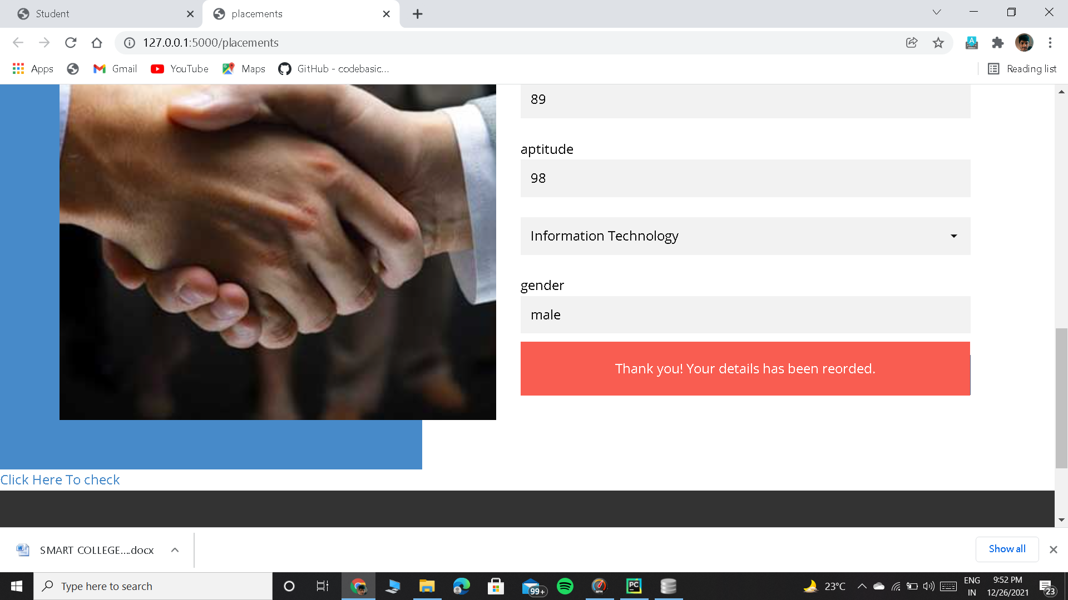

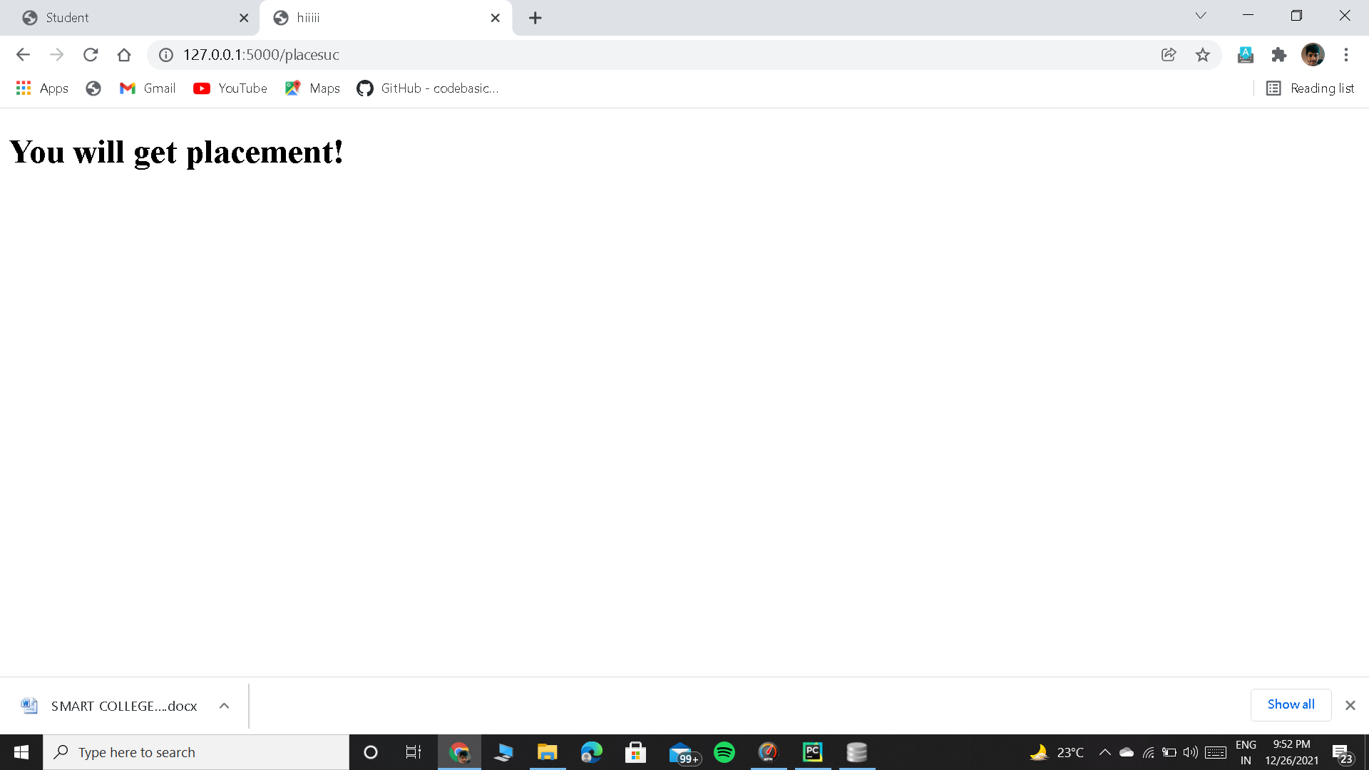

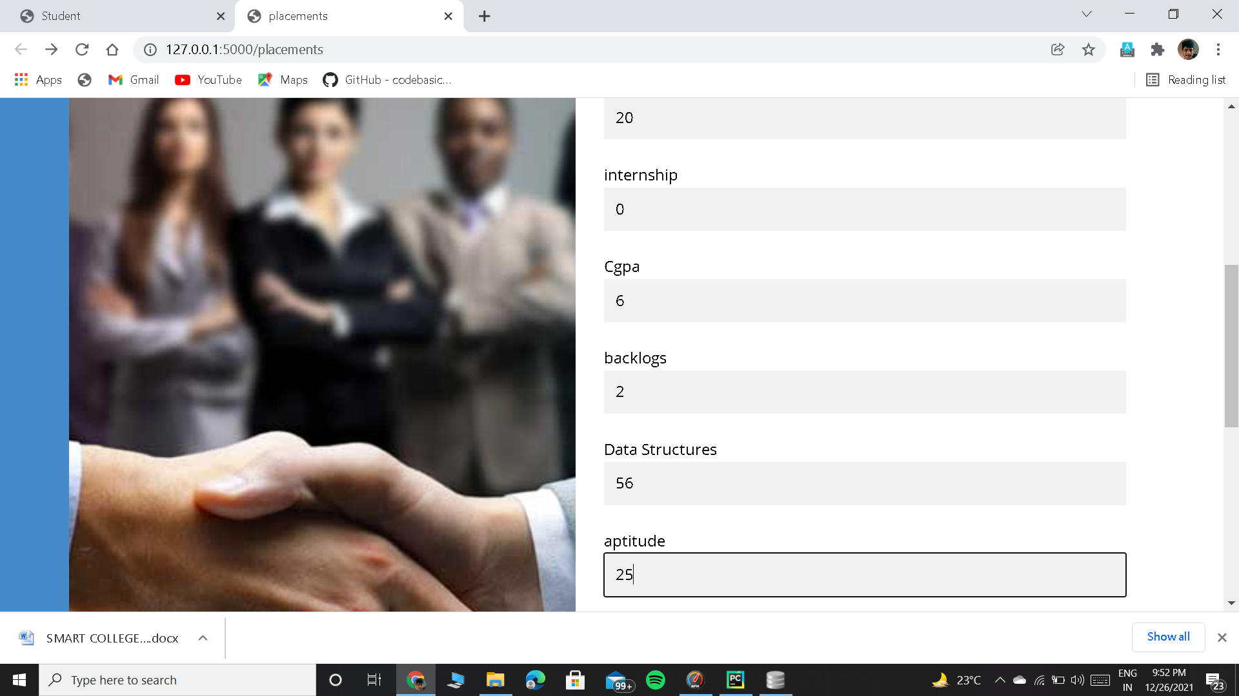

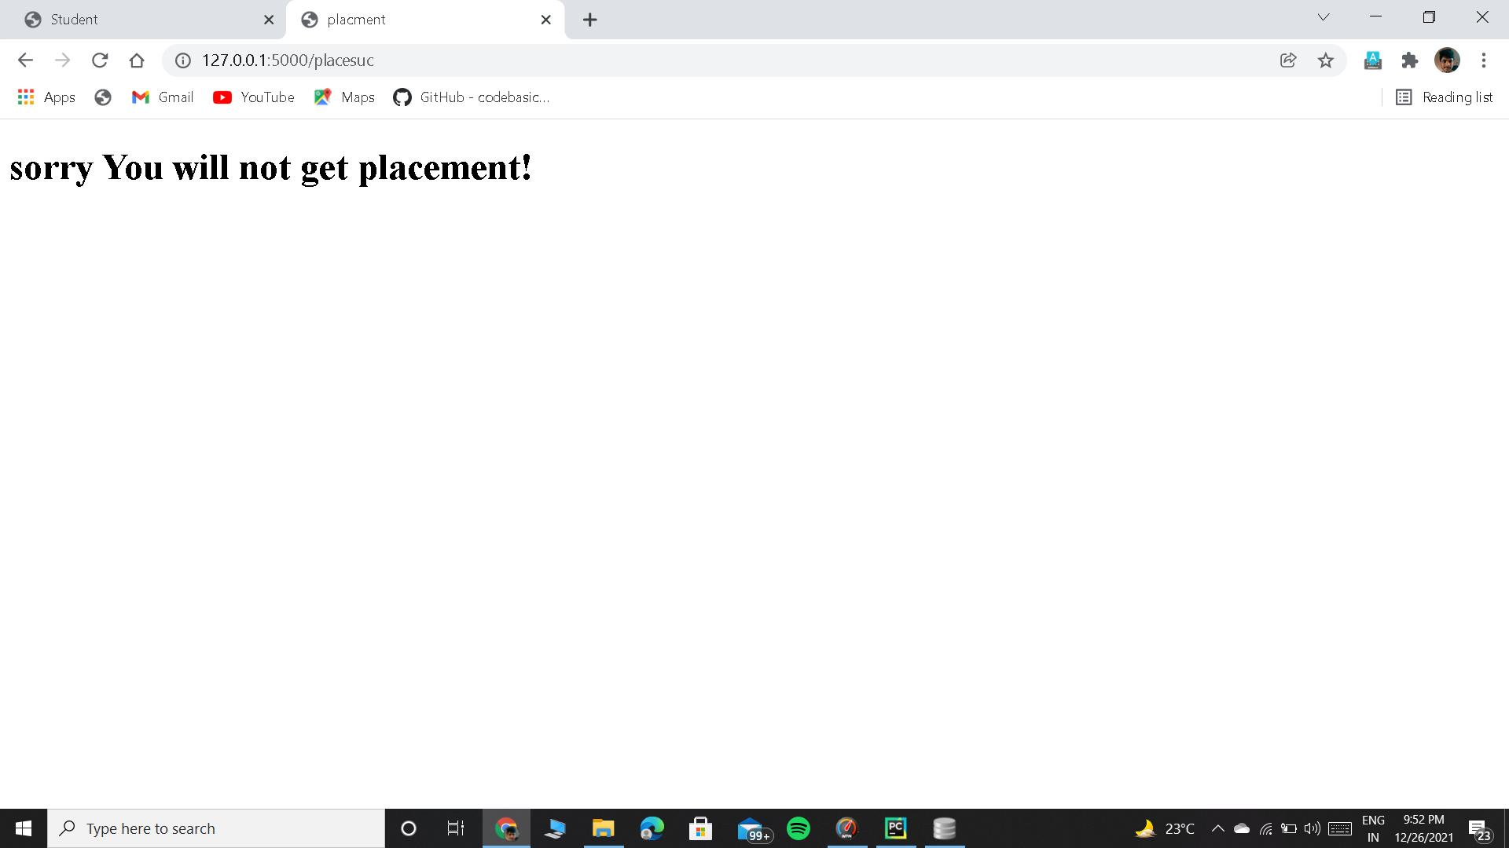

**Teacher Signup**

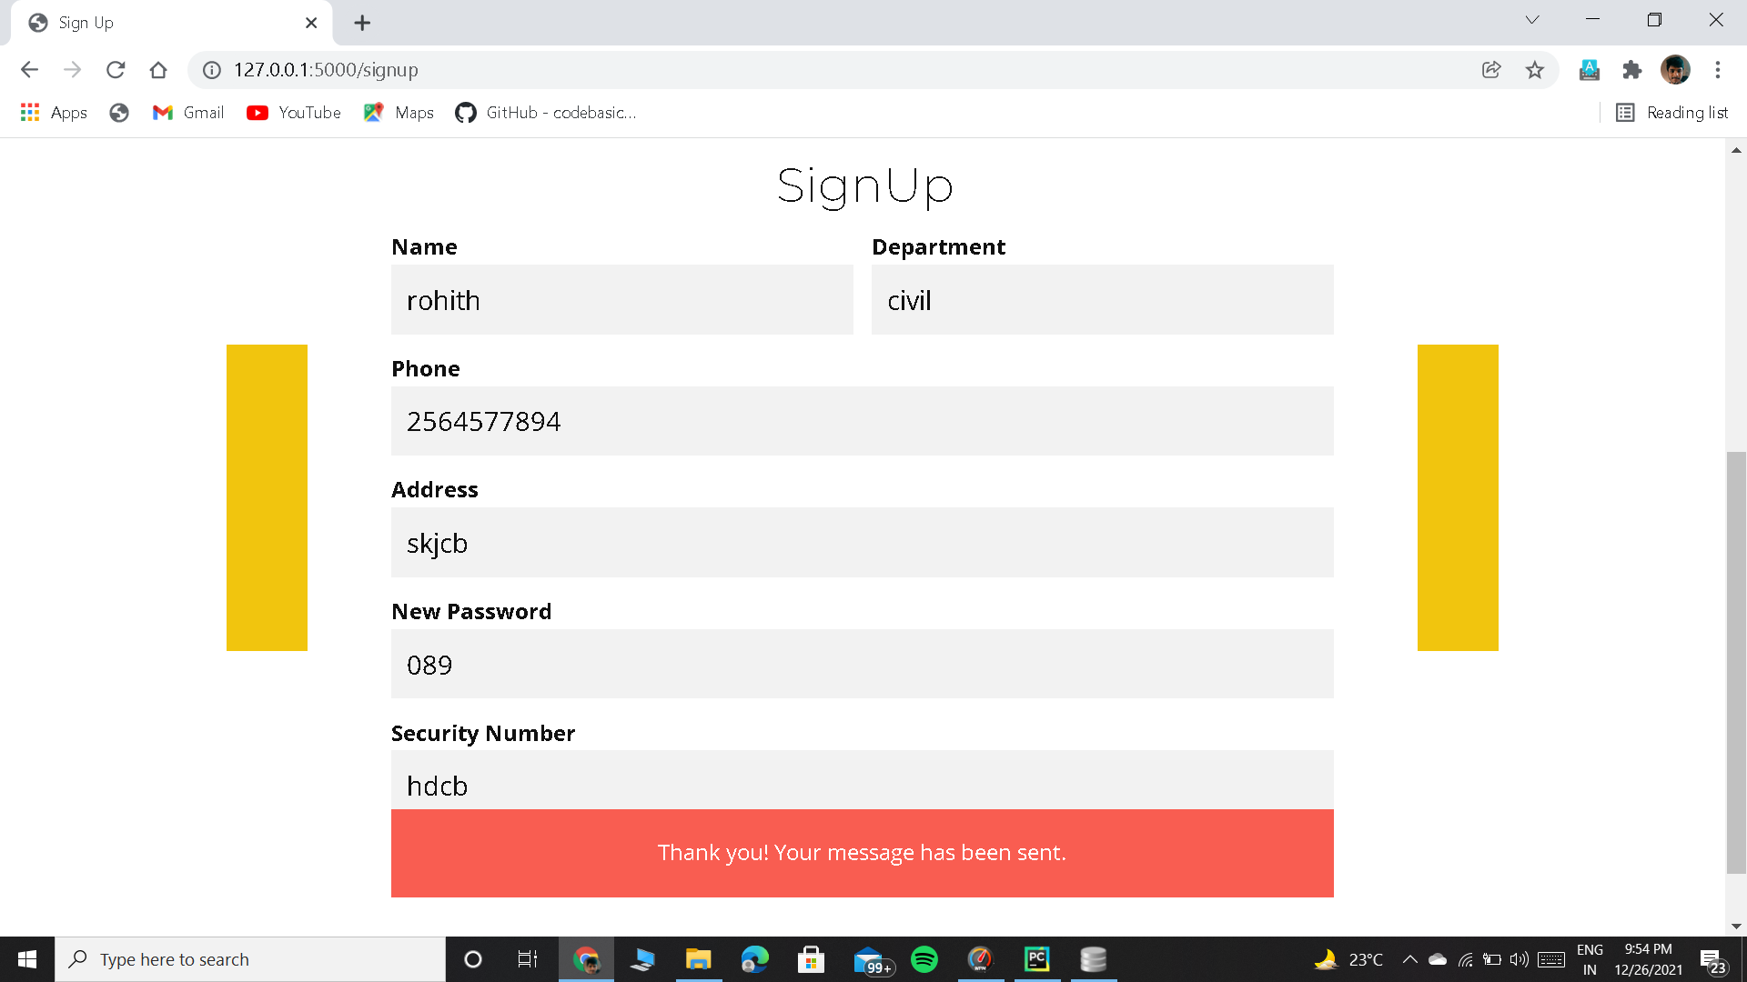

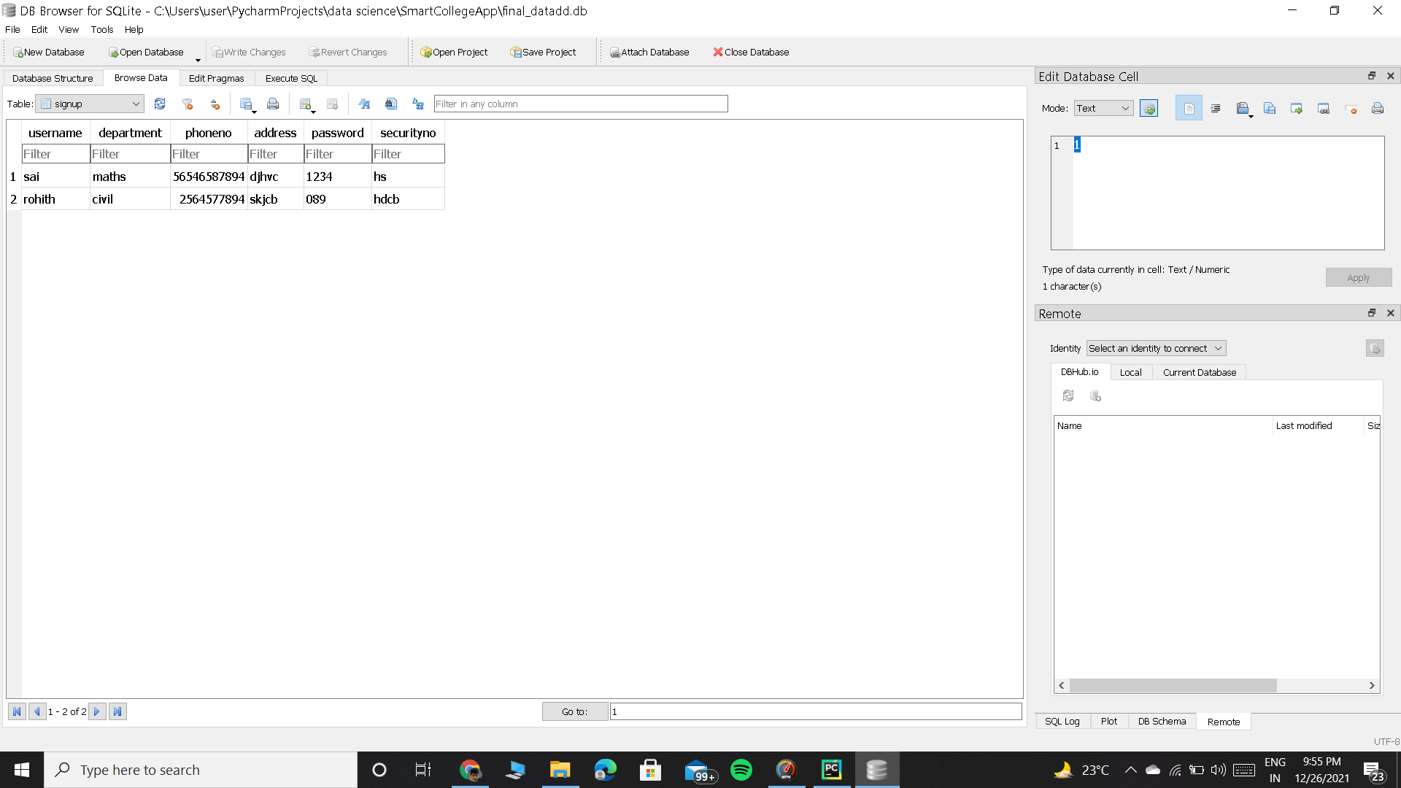

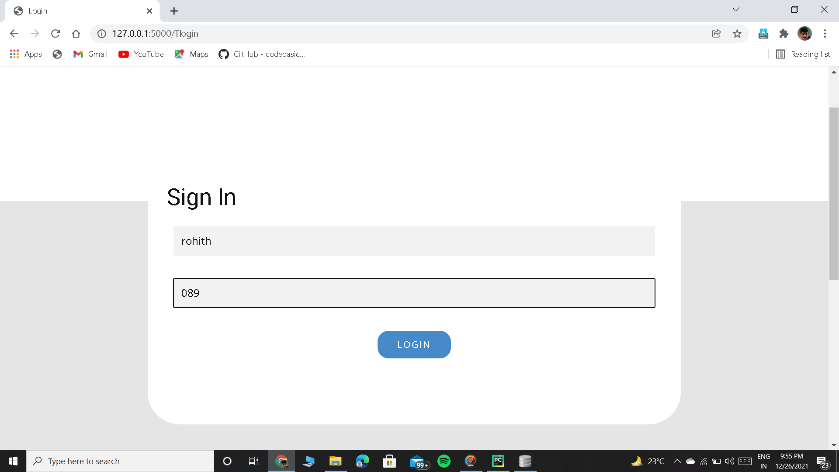

**Teacher Home Page**

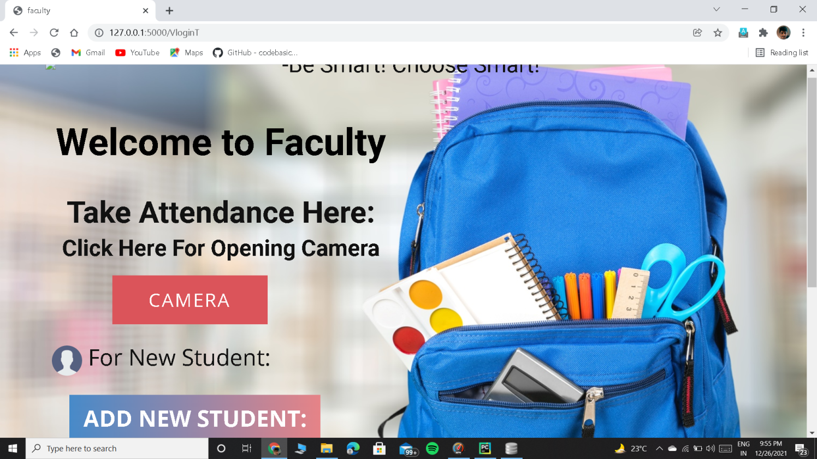

**Teacher capturing the image**

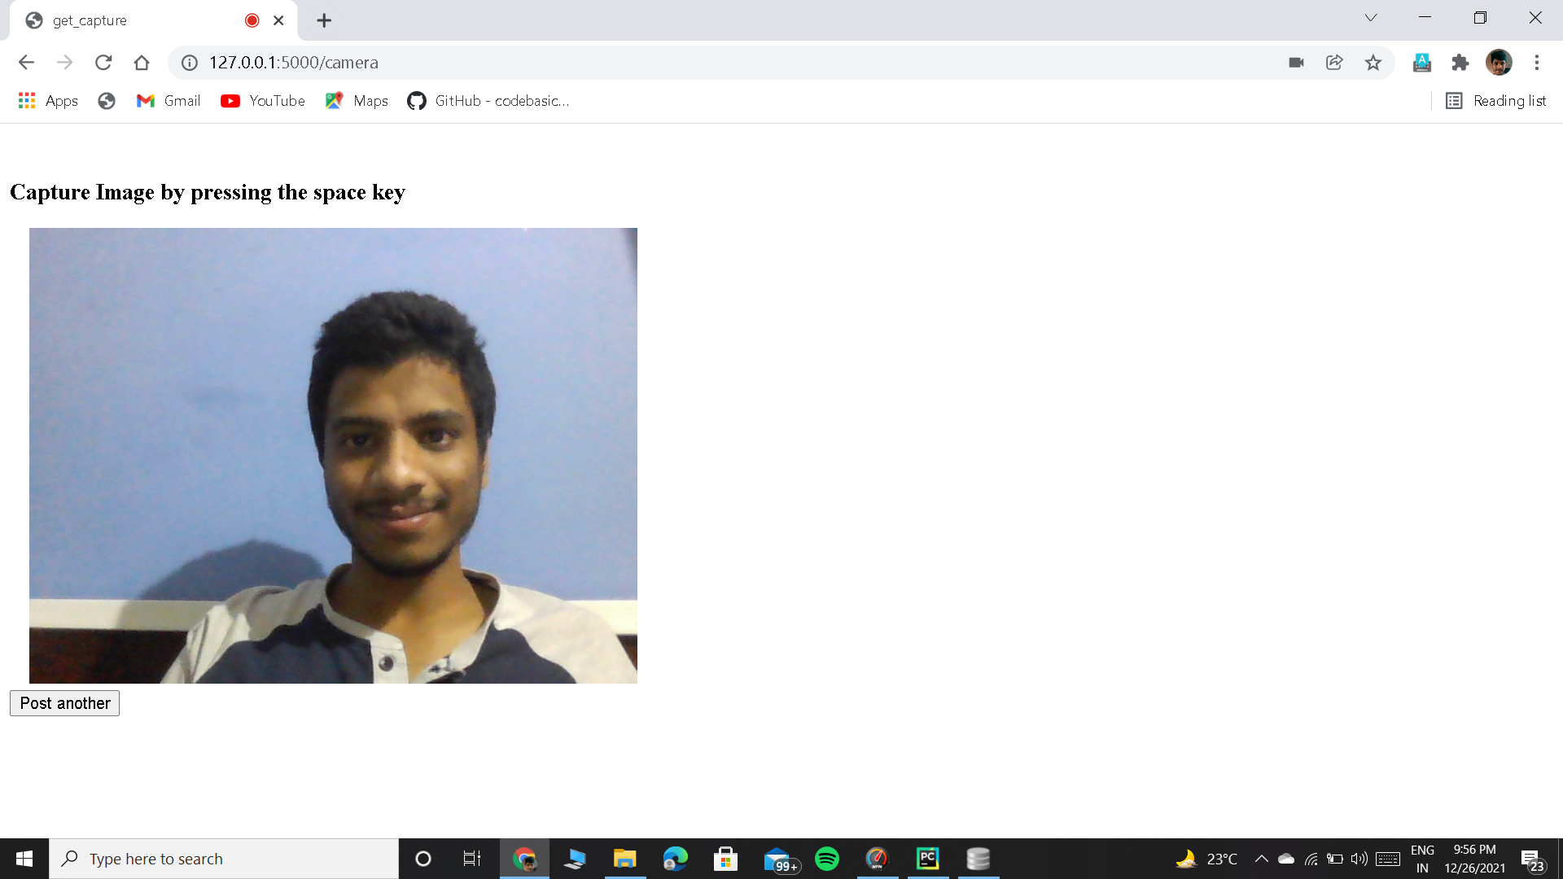

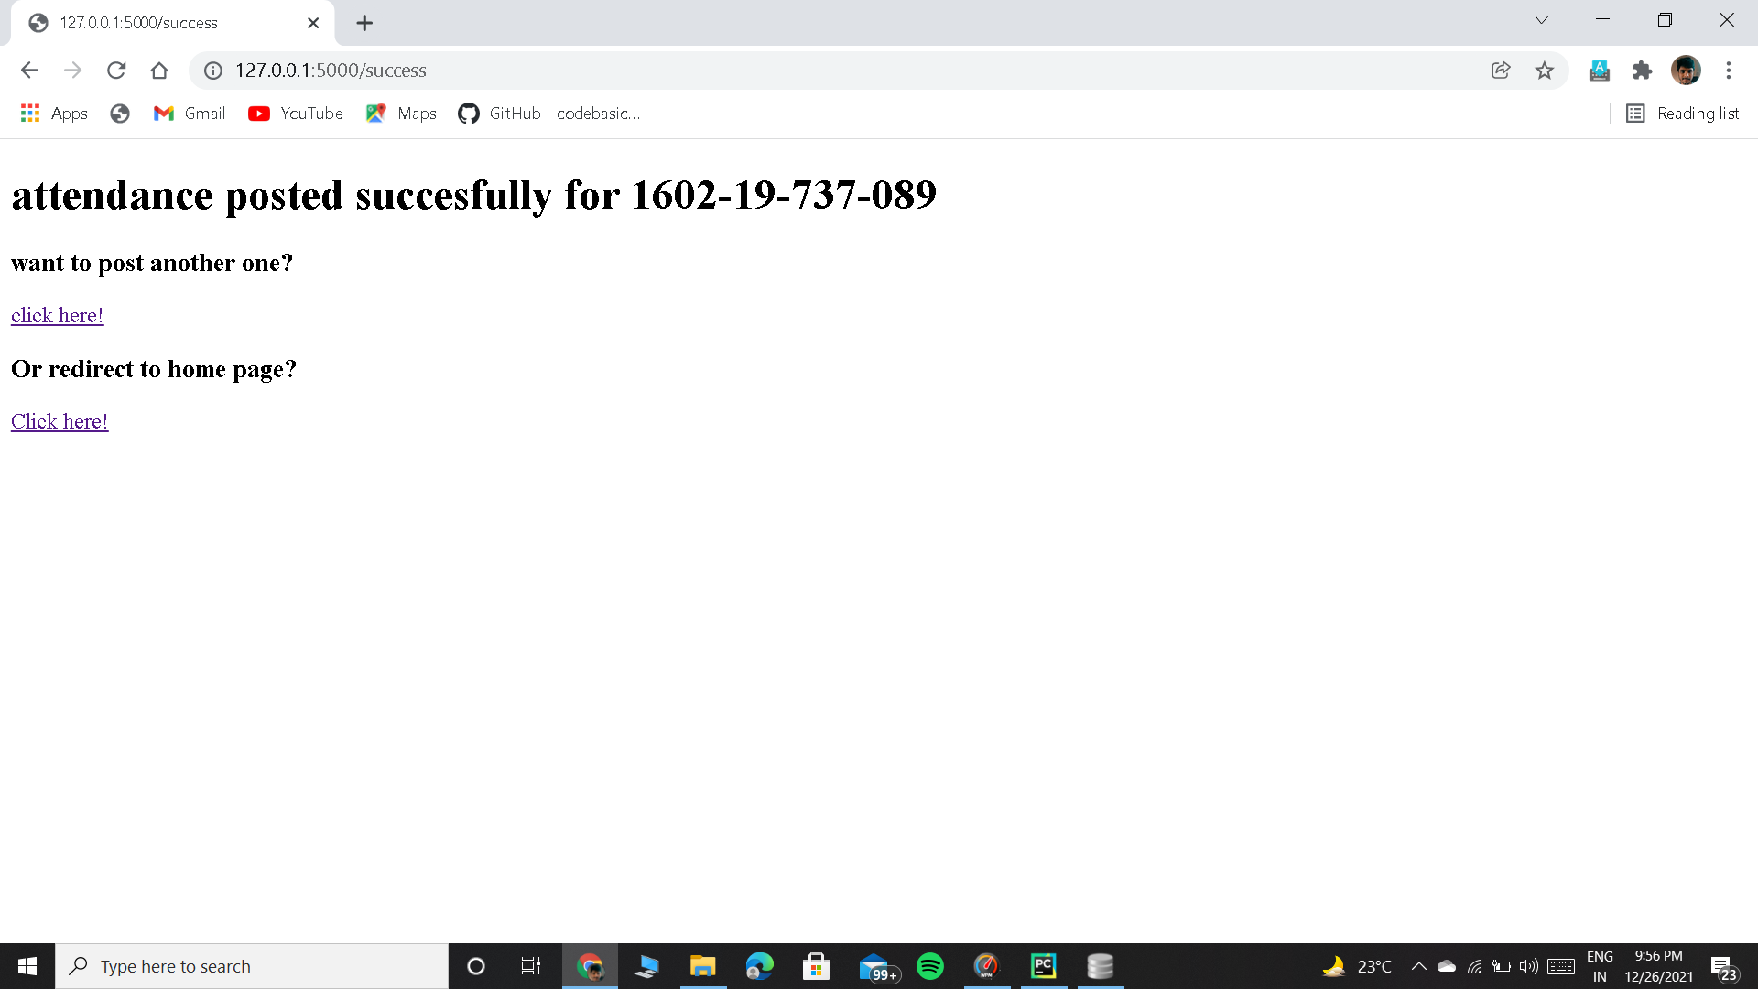

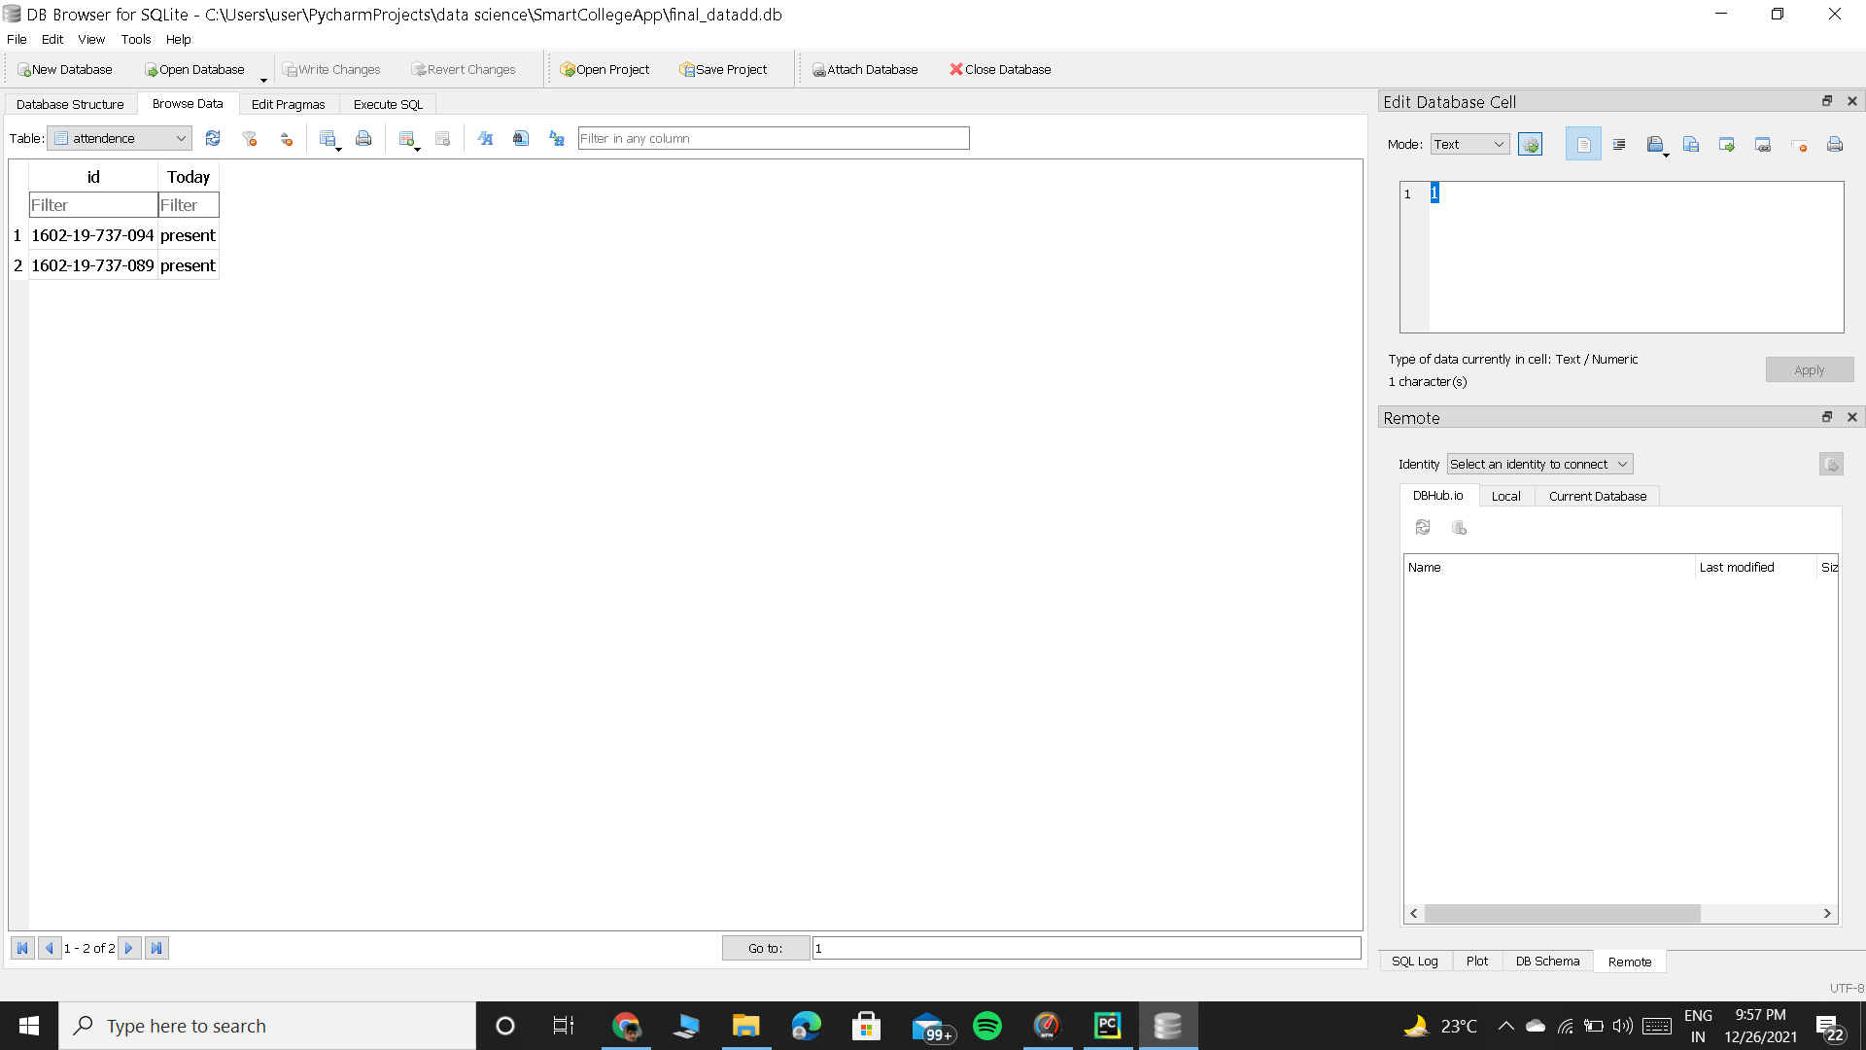

**6.1 Database Design:**

**(Mysqllite3)**

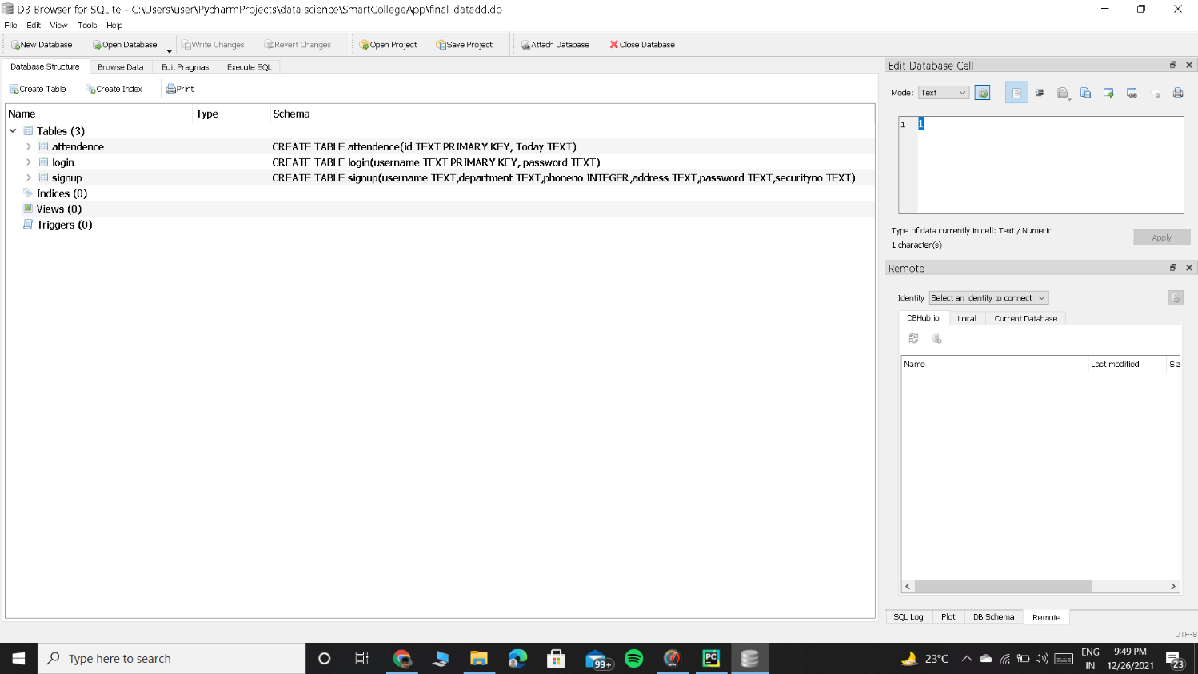

**TESTING**

* Password is validated using flask built in password hashing mechanism.
* Phone number is validated by checking the pattern=[0-9]{3}-[09]{3}-[0-9]{4} at admin input side using <input type="tel" pattern="[0-9]{3}-[0-9]{3}-[0-9]{4}">
* A valid teacher details are checked by comparing correct Enrolment date and enrolment number with the database values at the admin side.

**CONCLUSION**

**Conclusion:**

We believe that our website will be helpful for students and teachers who have or do not have any experience. Our website will be a one- stop-place to track attendance, for client users and will build a bridge between students and the peers.

**FUTURE SCOPE**

**Future scope:**

* An efficient chat system between the student and the chatbot can be introduced.
* Language translator can be introduced into the website so that people who are not comfortable with English can use.
* Based on the feedback from the user(s) modifications on the website can be done.

**REFERENCES**

* http://dlib.net/
* <https://getbootstrap.com/>
* <https://docs.opencv.org/4.x/d9/df8/tutorial_root.html>
* <https://flask.palletsprojects.com/en/2.0.x/>
* https://scikit-learn.org/stable/modules/svm.html